California Water Course
Water System Self-Assessment
By Dr. Samuel Sandoval Solís

Edited by Dr. Laura Elisa Garza Díaz, Dr. Erik C. Porse and Dr. Sooyeon Yi

Water System Self-Assessment

Introduction

This self-assessment is designed to determine the current conditions, future threats and alternative water management strategies of your water systems by gathering information and data that will improve your understanding of the water system of your interest.

Keep responses brief enough and provide references (weblinks/webpages, citation of document/papers and others whenever they are available) so that you can quickly dive deeper, if necessary. In cases where you do not have information, simply acknowledge what you do not know and discuss it with the instructor during the in person meetings how can you get that information. Do not get discouraged if you cannot find information right away, contact your classmates and ask where they found similar information. Remember that 80% of the time is typically spent in gathering information.

Each of the four sections will likely be completed by using the references, databases and websites provided in this document. However, if a website link, document or database does not work, please report it with the instructor and look for alternative information sources. Remember that you will be gathering information from different data sources, so, chances are that not all those sources may be available. You can also ask some of the organizations (through email) about the information that you are looking for, there is no harm in requesting information. A spreadsheet format is available upon request. When using multiple copies of this document, please list your name and date of last version on the header of each document.

Module 1 – gathers the basic data related to your water system and its spatial extent. This information come from local, state and national databases and resources already available. This information is important because it will provide you a deeper understanding on the natural and human-made aspect of your water system. You will also identify current threats that your community, tribes and local disadvantaged communities are likely to experience due to climate change, economic activities, etc. At the end of this module, you will have a deep understanding of the natural and human components and threats of your water system.

Module 2 – identifies the water policies and related that apply to your water systems, they are dependent on the location of your water system. This information come from statewide databases, state legislation, local ordinances, among others. This information is important because you will recognize and comprehend the array of policies your water systems is subject to, as well as the different decision making bodies that have an influence in your water system. At the end of this module you will identify, evaluate and maneuver the water policies that apply to your water system.

Module 3 – identifies the water management plans already developed for your water systems. Using a water balance approach, you will perform a diagnostic for your water system, what are the current threats and solutions already thought. The water plans evaluated in this section comes from: the California Water Plan Updates, California Groundwater Plans (Bulletin 118), integrated regional water management (IRWMs) plans, Urban Water Management (UrWM) plans, Irrigation Districts Water plans, Groundwater Sustainable Plans (GSPs), among others. Analyzing all these plans is important because they provide a diagnostic of the conditions of your water system. At the end of this module you will develop a water diagnostic for your water system that identifies current management strategies and you will propose alternative water management strategies.

Question? Suggestions? Contact Dr. Samuel Sandoval Solís at samsandoval@ucdavis.edu

Other relevant courses of water in California
(1) California Water Virtual Tour for overview of water conditions in several regions of the state of California,
(2) Growing water smart for linking land use and water management, delivered by the Sonoran Institute
(3) WELL untapped program focused on training local elected officials on obtaining relevant information, delivered by Water Education for Latino Leaders.
(4) Water Education Foundation Water Tours providing experiential knowledge on California Water Systems,
(5) Community Water Leaders Network (CWLN), a water leadership course for community members lead by the Community Water Center. Also, this center provides the drinking water guide, an outstanding guide for community members and water advocates to defend their right for access to safe, clean, affordable and accessible water.
(6) Self-Help Enterprises, Environmental Defense Fund and Rural Community Assistance Corporation. Water Leadership Institute, a water leadership course for community members,
(7) Central Valley Partnership has training programs for community member related with water, labor and land,
(8) California Indian Water Commission provide training and support to tribal and non-tribal members related to issues related water rights, water quality, quantity, access, natural resources stewardship, among others.

Module 1: Characterization of your water system
Resources: Guidebook (page 4 to 5) OR videos (1 and 2).
Defining your water system | Response |  | Notes or specific numbers
- What is the name of the water system that you are interested?
- Why are you interested in your water system?
- Provide a map with the location and spatial extent of your water system
- In which basin is your water system located?
- In which sub-basin is your water system located? (if applicable)
- Are there any groundwater basins or aquifers in your water system? | Yes | No
- List all the groundwater basins or aquifers in your water system (If applicable)
- List all the Disadvantaged Communities (DACs) located in your water system
- List all the tribes that are located in your water system

Resources: Guidebook (page 5 to 6) OR video(3).
Defining the Natural Elements | Response
- What is(are) the main natural landscape(s) of your water system?
- Describe the main orographic features of your water system
- List relevant soil types in your water system
- List the land cover and vegetation of your water system
- Select the climate(s) that are present in your water system | Semi-arid |  |  |  | Arid |  |  |  | Mediterranean |  |  |  | Cool/Cold |  |  | Highland
 | BSh | BSk |  | BSkn | BWh |  | BWk |  | Csa | Csb | Csbn |  | Dsb | Dsc |  | H
- Select the natural ecosystem(s) that are present in your water system | Coastal |  | Valley |  |  | Wetland |  | Riparian |  |  |  | Mountainous |  |  | Desert

Resources: Guidebook (page 9 to 11) OR video (5).
Event of the Water Cycle | Response
- Statistics for Precipitation | 1900-1960 | 1981-2010 |  | 1961-1990 |  | 2035-2064 | 2070-2099
- Sierra Nevada Current Snowpack
- Sierra Nevada Predicted Snowpack
- Temperature | 1961-1990 | 2035-2064 |  |  |  | 2070-2099
- Temperature |  | Low Emiss. |  |  |  | Low Emiss.
- Temperature |  | High Emiss. |  |  |  | High Emiss.
- Evapotranspiration | ETo Zone |  | Annual ET₀ |  | Avg. Precipitation mid-century
- Aquifer Storage | Elevation 2014 (fasl) |  | Elevation most recent year (fasl) |  | Overall increase, decrease or about the same
- Water Storage | Reservoir(s) |  | Storage

Natural Streamflow Classes | Response
- Major drivers of the natural streamflow classes in your water System | Snow Driven |  | Rainfall Driven |  |  | Rain and Aquifer (Low Elevation)
- Select the natural streamflow classes that are present in your water system | SM | HLP | LSR | WS | FER | HSR | GW | PGR | RGW
- List and describe the type of streamflow classes that are located in your water system

Defining the Human-made Elements | Response
- Does your water system is supplied of water from a large water infrastructure project? | [ ] Central Valley Project. Dams: Shasta, Trinity, Friant, Whiskeytown, Keswick, San Luis, Folsom, New Melones, Black Butte. Conveyance: Delta-Mendota Canal, Madera Canal, Friant-Kern Canal, Madera Canal, Tehama Colusa Canal, San Luis Canal, Pacheco Conduit, Santa Clara Conduit, Hollister Conduit, Corning Canal, Coalinga Canal, Contra Costa Canal, Clear Creek Tunnel. Clifton Court Forebay. Tracy Pump Plant (Fig. ES-4, Pg. 9). Mostly Agriculture.  [ ] Other Federally built infrastructure. Dams: Pine Flat, Kaweah Lake, Lake Success, Lake Isabella, New Melones Lake, Lake Berryesa, Lake Sonoma, Lake Mendocino, East Park Reservoir, Stony Gorge Reservoir, Cachuma Reservoir, Lake Casitas, Twitchell Reservoir. Mostly Agriculture with Urban users.  [ ] State Water Project. Dams: Oroville, Antelope Lake, Frenchman lake, Lake Davis, Pyramid Lake, Castaic Lake, Silverwood Lake, Lake Mathews, Lake Perris, Diamond Valley Lake, Lake Skinner. Aqueduct: California Aqueduct, North Bay Aqueduct, South Bay Aqueduct, Coastal branch, East branch, (Fig. ES-4, Pg. 9). Both, Agriculture and Urban uses  [ ] Colorado River. Dams: Lake Havasu. Conveyance: Colorado River Aqueduct, San Diego Aqueducts. Urban: Los Angeles and San Diego  [ ] Imperial and Coachella. Dams: Imperial, Pilot Knob, Lake Cahuila. Conveyance: All American Canal, Coachella Canal. Agriculture: IID, CVID, PVID  [ ] Los Angeles Aqueduct. Dams: Mono Lake, Grant Lake Reservoir, Lake Crowley, Owens Lake, Bouquet Reservoir. Conveyance: Los Angeles Aqueduct  [ ] San Francisco, SF Bay, Hetch Hetchy System. Dams: Hetch Hetchy reservoir, Lake Eleanor, Lake Lloyd. Urban: San Francisco and BAWSCA.  [ ] Mokelumne Aqueduct. Dam: Comanche Reservoir. Conveyance: Mokelumne Aqueduct.  [ ] Eel River – Russian River. Dams: Scott Dam, Van Arsdale, Lake Mendocino. Conveyance: Potter Valley Project.  [ ] North Marin (County) Aqueduct. Dams: Mendocino Lake, Sonoma Lake. Conveyance: Sonoma Water transport pipelines.  [ ] Not Applicable
- If it applies, include a map of your large water infrastructure system
- Does your water system is supplied of water from a small water system? | Yes or No | If yes, name(s) of your small water system(s):
- If it applies, include a map of the small water systems in Your Water System
- Write down the names of the irrigation/water district that are located in Your Water System | Name(s) of the water district(s) that are located in your water system:
- If it applies, include a map of the water systems that are located in Your Water System
- Number of Points of Diversions (PODs) identified in eWRIMS GIS System: | Number of Point of Diversions (PODs)
- Include a map of the PODs shown in eWRIMS
- Link of the search
- Point of Diversion (PODs) permitted?
- Location of the Groundwater Wells in Your Water System
- Location of wells supplying water to Public and State Small Water Systems
- Is there a flood management reservoir in your water system?
- Floodplain area.

Water Quality | Response
- Map of water bodies listed [] for not meeting water quality standards who has a process for developing a Total Maximum Daily Load (TMDL)
- For one water body that is in the 303 (d) list, write down the primary and/or secondary Maximum Contaminant Levels (MCLs) that have been exceed or are of concern.

- Map of wells with groundwater quality data
- Number of wells exceeding an MCL | Chemical
- Number of wells exceeding an MCL | # of Wells

Optional – Overall Environmental Risk | Response
- Take a screenshot of the map in the CalEnviroScreen Data Dashboard of your water system.
- CalEnviroScreen indices
- List the three largest value indicators. | Pesticides, Impaired Water Bodies and Education.

Congratulations! You have completed Module 1 of 2!

Instructions to fill the Module 1 section

Defining your water system
Resources: Guidebook (page 4 to 5) OR videos (1 and 2).
In this activity, you will define “Your Water System.” This can be an iterative process as you move forward in the course, so don’t feel bad if you re-define your water system later. What we are looking in this activity is that you name a place and define an area of your interest that you will analyze throughout this course. We will provide you tools and databases to find most of the information that you need, such as natural and human-made elements, components of the water cycle, and policies that may apply. However, it is very important that you have some familiarity with the water system of your interest, so it is easy to find and describe your water system. Remember the definition of a water system:
“A water system is a group of natural and human-made elements in a basin that are linked naturally or because of human intervention where the water cycle occurs”
There can be different types water systems, such as your own home, the ranch or a property that you are interested, the city that you live or that you are interested in knowing more about, the county that you lived, a basin (e.g. Los Angeles River) or a larger region (e.g. Southern California).
Some examples of water systems can be found here:
- My own home
- City of Davis
- Pajaro Valley
- Russian River
- Clear Lake
- Sacramento basin

      - Write the name of the water system that you are interested to learn more about.
      - Provide the rationale for why you selected the water system. There can be plenty of reasons, such as:
        - it is the region that you live,
        - it is a region that you are aware it has problems with water (quantity and/or quality),
        - it is a region that has environmental degradation,
        - It is a region where diverse communities do not have adequate access to water as other more affluent communities
      - Provide a map of the water system that you are interested to know more about.
        - First, make a internet search for a map of the water system that you are interested to know more. If you find a map please copy the figure into this question and provide at the end the citation or link from where you found the map.
        - If you can’t find a map, there are different ways in how you can create your own map. Of course, you use specialized software (ArcGIS, QGIS) to create a map. However, there is an easy way that you can do this in My Maps of Google Maps. This webpage shows how to create a polygon in google maps that you can use to show the extent of your water system. Here is a link of a video that we create to show you how to draw your own map.

Identifying your basin
      - Identify the main basin that your water system is located. Here we will use a specialized tool: Online ArcGIS. Go to the following link of Online ArcGIS. We will need to add the following layers, so it will make it clear which rivers are draining each basin: North America Lakes and Rivers. To add this layer, click on the “Add” icon below the layer “California WDB HUC8 Watersheds” and in the “Search” tool type “North America Lakes and Rivers” and then click on “+ Add”. Now, click on the location of your Water System and a window will pop up with the name. This video shows how to do this procedure.
      - Identify the sub-basin that your water system is located. Here you will continue using Online ArcGIS. You will need to add the layer “Watershed Boundary Dataset HUC10s” as you did in the previous question. This video shows how to do this procedure.
      - Now that you are more familiar with your water system, basin and sub-basin, you have to identify if there is any groundwater resources (groundwater basins and/or aquifers) in your water system. Go to the following page and look for aquifers that are located within your water system. Instructions. Scroll down and accept the terms. On the bar menu on the left, click on “Reference Layers” that is at the bottom left corner of the page. Select “Bulletin 118 Groundwater Bains – 2018”. When this layer is activated, you can see all the groundwater basin in the state of California. Make a zoom to the location of your water system. Also activate the layers of “Watersheds” and “Major Rivers and Creeks” you can made them more transparent or opaque with the scrolling bar. This video shows an example of this task and the following two.
      - Identify all the groundwater basins that are located within your basin and write them down in this question.
      - Identify all the Disadvantaged communities that are located in the basin where your water systems is located and write them down. This video shows an example of this task.
      - Since time immemorial, tribes lived in California. First, go to the Native Land map, zoom into your water system and identify the territories of the tribes whose homelands are located in your water system. Second, identify all the Tribal communities that currently are located in your water systems and write them down. Go to the SGMA Data viewer, open the tab of “Reference Layers”, go to the section of “Political” and click on “Tribal Representation Tracts”, “Tribal Land Area Representation”, and “Tribal Leaders Directory”. Zoom into your water system and identify the different Tribes that are located within your water system.

Defining the Natural Elements
Guidebook (page 5 to 6) OR video(3).
      - Identify what are the main natural landscapes that are located within and surrounding your water system. This is where the familiarity with your water system becomes handy. This map shows the main landscape in California, which is a starting point. Look on internet for the natural landscapes that are located within and surrounding your water system.
      - Identify what are the main orographic features that are located within and surrounding your water system. This is where the familiarity with your water system becomes handy. This map shows the main orographic features in California, which is a starting point. Look on internet for the natural landscapes that are located within and surrounding your water system.
      - Identify what are the main soil types that are located within and surrounding your water system. This website shows some of the soil type properties. In the upper tabs, click on “Properties” then on “Physical” and scroll down and click on “Soil Texture (0 - 25 cm)”. Then zoom in the location of your water system. This map shows the different soil textures for the first foot of soil. Click on the “?” icon right next to the Soil texture triangle to read about the different soil texture classes. Write down and identify the main soils textures of your water system. This video shows an example on how to do this task.
      - Identify the Land Cover(s) that are present in your water system. You can use the information in this website to identify the land cover in 2010. Click on the “Open in Map” and wait some time for the database to upload. Then, zoom on the region where your water system is located and click on the “i” icon on the horizontal menu bar. The “i” icon or identify will pop up a window where it will display the category of the land use (e.g. Raster.WHRNAME Agriculture) and the sub-category (e.g. Raster.Class Strawberries). Also, you can take a look at the SGMA Data viewer, open the tab of “Water Budget”, go to the section of “Land Use Datasets” and click on the most recent year when land use data is available. Zoom into your water system and identify the different land uses and crops that are gown in your water system.
      - Identify the climate(s) that are present in your water system. You can use the information in this document (page 15) to select the climates that are relevant for your water system.
      - Identify the natural ecosystem(s) that are present in your water system. You can use the information in this website to select the ecosystems that are relevant for your water system.

What are the key event of the water cycle to remember?
Guidebook (page 9 to 10) OR video(5).

Precipitation
      - We will explore three data sets so you have an idea of how much precipitation has changed.
1900 – 1960. Go to Data Basin in the following link to access the Average Annual Precipitation for California, for the period 1900 to 1960. Click on “Open in Map”. On the upper left side of the map there is a menu with “Datasets” and the dataset that we are visualizing, “Average Annual precipitation for California, USA (1900-1960)“ Click on the arrow to the right that is right next to the previous text, then click on “transparency” and change to “60%”. Now zoom on the region where your water system is located, click on the information icon “i” () and click on one location of your water system. A window should pop-up showing the pop, the field of “PRECIP” displays the average annual precipitation in inches for that location for the period of 1900 to 1960. Write this value down. If you want to explore different locations, write them down, but make sure you click on the same locations.
1981 – 2010. Go to the link of the Online Arc GIS that we used before. Click on “Open in Map Viewer”. On the right hand menu change in “Appearance” the “Transparency” bar to 35% and zoom into the region of your water system. Now click on the same location(s) of the previous dataset. A window should pop-up showing the average annual precipitation in inches per year. Write it down.
1961-1990, 2035 – 2064 and 2070 – 2099. Now, we will visit Cal-adapt, it is an amazing data tool to explore mid- and end-century projected data considering climate change (medium and high emission scenarios). Click on the following link of Cal-Adapt Annual Averages, click on “Change Location”, a Window should pop-out. In the map of the left move to the region where your water system is located. Click on the grid that is the closest to the locations that you used before and in the menu at the bottom click on “Confirm”. This action should retrieve the annual averages for that grid. Below the map of the right there should be a drop-down menu to “SELECT THE CLIMATE VARIABLE”. In this drop down menu select “Precipitation”. Now the window shows the Annual Average Precipitation of the baseline period (1961-1990), Mid Century (2035-2064) and End-Century (2070-2099) for Medium Emissions (RCP 4.5). Write down the “30 YEAR AVG” for all these periods. Also write down the “30 YEAR RANGE“ values, which shows how much precipitation will range. For California, many times it is not that the average precipitation will change dramatically, what it changes is the range or in other words, its variability. Now, change the emission scenario, on the right menu in the “SELECT SCENARIO” section click in “High (RCP 8.5)” and write down the “30 YEAR AVG” and “30 YEAR RANGE“ for the high emission scenario.

Snowpack
      - Current Snowpack. Almost every community, city, or place in California depend (directly or indirectly) in the Sierra Nevada snowpack. Let’s take a look at the historic and predicted snowpack for the Sierra Nevada. Go to the interactive snowpack webpage of DWR, and select the current year, two wet years [wettest: 2016-2017 , 2018-2019) and two dry years (driest: 2014-2015 and 2021-2022) and click on “Draw Chart”. For a quick summary of the snowpack with respect to the statistical average, take a look at this DWR webpage.
      - Predicted Snowpack. Go to CalAdapt - Snowpack and explore the snowpack. Go to the tab of “Map” then on the left menu select “Medium (RCP 4.5)”, select the month of “April”, select the period of “10 years” and select any climate model of your preference. Then click Play () below the legend’s figure. You will see a depiction of how much snow (as snow equivalent) has historically happened and is predicted until the end of the century. We selected April because April’s snowpack is the maximum amount of snowpack that is available for summer considering that all the large storms have already passed and it is the beginning of the snowmelt season. Copy in your form a picture of the snowpack at the end of the century.

Temperature
      - Let’s explore the impact of temperature in your water system. Go to CalAdapt – Climate Change Snapshot, in the map, zoom into the location of your water system, select “Watershed (HUC10)” and click on the HUC that is related to your water system. Then click on “GENERATE SNAPSHOT”. Write down the “30yr Average” temperature in the form. For temperature, trends are upward, no matter in which part of the state your water systems is located. Increased temperatures will have an effect in other events of the water cycle, such as evaporation, evapotranspiration, etc. Also, increased temperatures will affect disproportionally disadvantaged communities that may not access to adequate air conditioning or whose jobs are exposed to temperature, e.g. farm workers. In the same webpage, in the dropdown menu of “SELECT CLIMATE INDICATOR” you can choose “Extreme Heat Days” and you can see how many extreme heat days will occur by mid and end of century.

Evapotranspiration
      - We are lucky to have CIMIS in the state of California. CIMIS (California Irrigation Management Information System) is a group of weather stations that calculate reference evapotranspiration throughout the state. Open the Reference Evapotranspiration Zones Map, go to the map on page 2, identify in which Reference Evapotranspiration (ETo) zone your water system is located and write it down on the form. Then go to page 3 take a look at the monthly average reference evapotranspiration. Write in the form the total reference evapotranspiration (value of the last column), which is the average annual vale. From the section of temperature (#18) copy the average precipitation for the mid-century. Compare this two values. Many time the reference evapotranspiration is greater than the precipitation, meaning that a well-watered grass uses more water than what it rains in that given location. Also, many crops use more water than a well-watered grass, meaning that rainfall not only falls in winter when is not needed for crops, but also that if we were able to capture all that water, it would not be enough to meet the crop water requirements.

Aquifer Storage
      - It is very difficult to estimate aquifer storage because it is very difficult to estimate que water storage in aquifers. However, one way to estimate how much water an aquifer has it to compare the water levels (the water table) through time. Go to the SGMA Data viewer, click on the “Ground water Levels” tab, in the section of “Seasonal Reports” select “Elevation”, select the season of “Fall” and “Select year” 2014. The check the box of “Elevation Points” , it will show the feet above sea level (fasl). What you are seeing is the estimated groundwater elevation in 2014. Zoom to the location of your water system and identify a well that is close to your water system. Write down the elevation, sometimes you can have negative elevations when the water table is below the mean sea level. Then go to the most recent year and write down the groundwater elevation. Then compare if the groundwater elevation has increased, decreased or about the same.

Water Storage
      - There are plenty of surface water reservoirs in the state of California, more than 1,000! Now, let’s identify the reservoirs that are located in your basin. Go to the CDEC-DWR Daily Reservoir Reporting Stations and look for the reservoir(s) that are located in your basin. When you identify the reservoir in your basin, click on the “ID” of the reservoir, it is a three letters acronym of the reservoir that is right next to its name. A new window should show up, that shows the Date, reservoir elevation (RES ELE), Storage (STORAGE), and reservoir change. Click on “STORAGE”. A window with a graph should appear, then change the “Span:” to 1000 days, so we can take a look at the last three years of storage. Take a screen shot of the graph and past it on your form.

How water moves naturally in California?
Guidebook (page 9 to 10) OR video(5).
      - Take a look at this map (you can also download it) of the natural streamflow classification of California, and roughly identify the natural streamflow classes that are located in your water system.
      - Go to the eflows website and click on “Hydrology”. On the map of the left, zoom into your water system location and with your mouse, hover over the rivers. You will see that the name of the natural river classification on the mouse cursor. On the list of river on the left you can see the name of the streamflow classification as well as its abbreviation in parenthesis. Using the abbreviation, select the natural streamflow classes that are located in your water system.
      - Using the following table of the natural streamflow classification, write down the names of the classes located in your water system and briefly describe/summarize the information from the table that are relevant to your water system.
Just for your reference (you don’t have to read them), all the information for this section is explained in the following peer-reviewed documents: Lane et al. (2018), Patterson et al. (2020).

What are the Human-made Elements of my water system?
Here comes the tricky part, which is to identify the human made elements considering that there has been a lot of infrastructure built throughout the state. Please take a look at the figures and text of this cartoon pamphlet that provides a good overview of the California water system. The first step is to evaluate if your water systems is supplied by large water projects, and the second step is to evaluate if it is supplied by more local water project.

Large water infrastructure and small water systems
      - Large Water Infrastructure Projects. Take a look at the executive summary of the California Water Plan Update (pages ES-9 to ES-10) where the large water systems projects are depicted (page ES-9) and all the rivers and places that share their waters through infrastructure to other region for agriculture and cities (page ES-10). This can provide you a first pass to identify if the location of your water system is supplied by large water infrastructure systems. Take a look at the maps of TNC’s whitepaper (pages 14 to 31) that provide a closer look to the different large water project infrastructure in California. Now in this section of your form, you have links of figures for every large water infrastructure project. Identify if any of them supply water to your water system. Select the large water system if it applies to your water system.
      - If it applies, include a map of the large water infrastructure that your water system receives water from.
      - Small Water Systems. Your water system may be supplied from a small water system. The Community Water Center (Centro Comunitario para el Agua) Drinking Water Tool is a great tool to identify small water systems. When you open the CWC Drinking Water Tool scroll to the bottom and click on “Your Water Data” and select the language of your preference. A pop-up window should appear, go to the section of “Step 1” and type an address, the name of a city, or the zip code. In “Step 2” select if your water system is supplied from a “Water System” or a “Domestic Well”. If you are not sure about the water source, then click “Water System”. Four results will be displayed: (1) Who manages my water?, (2) What about water supply?, (3) What about water quality? And (What about drinking water treats?. For now, let’s focus on “Who manages my water?” This section will tell you who manages the surface and groundwater of that region. Write the name of the agency(ies) and the source of water for your system.
Important: If it doesn’t come any results in Step 1, you can go back to the CWC Drinking Water Tool scroll to the bottom and click on “California Water Data”, select the language of your preference. Select “Skip” and on the menu of the left select toggle “Water Systems”. Then zoom in to your water system and click on the location. It should show the small water systems and the agency that is providing the service to your water system. Write it down. Click on the print icon () to print the data of your small water system. Download these data as a pdf file. Include a screenshot of the file in your form for # 27.
      - Click on “Explore the Map”, check the box of “Public and State Small Water System Boundaries”, “Public Supply Well Locations” and activate “Water System” toggle. Now click on the location of your water system. On the menu bar of the left it should come the information of your water system. Right next to the name of your water system, there should be an icon () to print the data of your small water system. Download these data as a pdf file. Include a screenshot of the file in your form.

Irrigation and water districts
      - Irrigation/Water Districts. The largest user of water is agriculture (for consumptive use). Thus, it is important to know the water and irrigation districts that are located in your water system. Go to the data basin website, click on “Open in Map” and this map shows you the different water districts in California. Zoom to your water system and click on a given location. If there is a water district, a window will pop up with the number of water districts that have jurisdiction over your region. Notice that there are arrows “>>” on the upper right corner of the pop up window, so you can see how many water districts have a jurisdiction over the location that you clicked.
      - If it applies, take a screen shot of the water systems that are located in your water system and paste this picture in your form.

Surface water users
      - Surface Water Diversions. Now we will explore the surface water Points of Diversion (POD) on our water system. Go to the electronic Water Rights Information and Management System (eWRIMS) which is a database of all the surface water rights maintained by the California State Water Resources Control Board. eWRIMS will sunset in 2025 and CalWATRS will replace it, but in the meantime, let’s use eWRIMS. Let’s go to eWRIMS GIS System and click on “Find water Rights”, then check the box of “HUC Watershed number”, click on “Search”, and them provide the HUC10 number that you identified for your water system in #5 of this form (e.g. for the Pajaro Valley example the HUC number is 1806000208). Then click “Search” again. A new window will come showing you a map with all the PODs (point of diversions) for surface water rights, the bar on the left shows the total number of PODs, and if you move your mouse over the PODs, it will highlight in the map where they are located. In the form write down the number of PODs located in your water system
      - Map of diversions. Take a screenshot of the map displayed in eWRIMS and paste it in the form.
      - Link of the search. In the bar of the upper left corner of the map, there is a test that says “I want to …” click in it, and select “Save”. A window should pop-up asking you about the name of this project and other questions. There should appear a URL link of the project, copy and paste the link in the form, so next time that you want to check on this results, you can always come back.
      - Downloading PODs records. On the bar of the left, there is a icon that displays a drop down menu. In that drop down menu select “Export to XLSX” and save this file. This is a very important file, because it contains the PODs the data of all the legal point registered to diver surface water in your water system. You can explore this file, specially to know the name of the individuals or companies with a POD (Columns AV and AW), if this permit is active (Column AN), the diversion amount (Columns AK and AM), the storage amount (Column AL) and units (Column AU), and the water right type (Column AR), just to mention a few. Identify how many PODs are “Permitted” (you can filter these data in excel) and write it down on the number of PODs in your form.
IMPORTANT: You can also search PODs and water rights in eWRIMS on your own, this webpage describe common searches and a dictionary of terms.

Groundwater users
      - Groundwater Diversions. We will use two databases to identify the wells in your water system that are the groundwater diversions points. In the SGMA Data viewer, in the left bar, go to “Groundwater Levels”, then go to the “Well Completion Reports” section and select “Well Completion Reports”. You have to zoom in to see the wells. The map will show the location of wells that have been drilled since 1949. This map provides a good idea on the number of wells located in your water system. Also, in the same section of “Groundwater Levels” , subsection of “Monitoring Network” select “DWR GW Measurements”, it will show the location of monitoring wells maintained by DWR. Take a screen shot of the map and paste it on your form. Now you know the location of the wells in your water system.
      - Public Supply well and State Small Water Systems wells. Now let’s identify what are the location of the public supply and small water systems wells. In the Drinking Water Tool of the Community Water Center (Centro Comunitario por el Agua), select “California Water Data” at the bottom of the webpage. on the left bar, in the “Groundwater Users” section, check the boxes of “Public Supply Well Locations” and “State Small Water Systems”. Zoom in to the location of your water system. This dataset shows you the location of well that are supplying water to public and state small water systems.

Floodplain areas
      - Flood Management Reservoirs. Let’s switch gears here a little bit. Now, let’s identify if there are dams in your water system that are operated for flood management. Go to the US ACE website (United States Army Corps of Engineers) and identify if there is a reservoir that is owned or operated by the USACE (Section 7) that influence your water system. If so, write its mane in the form.
      - Floodplain Inundation Maps. Now, let’s explore the flood inundation maps using the National Flood Hazardous Layer (NFHL Viewer) of FEMA. Zoom in the location of your water system. Maps of the floodplain area will appear as you are zooming in to your water system. Take screen shots of the floodplain area of your water system. If you water system is larger that the screenshots, then take several screenshots and overlap them in power point to create a mosaic of figure to show all your water system.

Water Quality

Rivers and Water Bodies
      - Water Quality in Rivers. The SWRCB has the Surface Water Quality Assessment Program that reports water quality in surface water bodies. This program puts surface water bodies (e.g. rivers, reservoirs, lakes, estuaries, and even ocean waters) in a list [303(d)] that initiates the process to develop a TMDL (Total Maximum Daily Load) or another restoration project to restore or maintain water quality standards. This program also develop a report, “305(b) report” that assigns an overall water quality condition to all water bodies, it is submitted the US EPA for the National Water Quality Inventory Report. Go to the latest California Integrated Report Map, and explore the surface water bodies (e.g. rivers, lakes, etc.) of your water system. Zoom in your water system. The main menus of this GIS tool are located in the upper right corner. If you click on the legend icon “” you will see that water bodies are depicted in two types of green: (1) dark green color for those water bodies listed in the 303(d) list of which a TMDL should be developed, and (2) light green color for those water bodies not listed. If you click on a water body (e.g. river or lake) a window should pop up providing information related to the regional water quality board, and the listing status: listed or not listed. If you keep scrolling down in this window, a link of the “More info” should come up, click on it and you will see a list of all the test done for primary and secondary Maximum Contaminant Loads (MCLs), the Line of Evidence (LOE), and if the water body is: listed, do not delist, not listed, or delisted for a given MCL. Take a screenshot of the map and paste it in your form.
      - Impaired water quality constituents. Click on a surface water body of your interest in your water system, for example, the mainstem of the river that passes through your water system. Then, scroll down on the pop-up window that came up and click on “More info”. Typically, the impaired pollutant or the impaired water quality parameter are listed at the top of this screen. Every pollutant is identified by a green horizontal bar displayed across the window. In your form, write down the name of the river and the list of pollutants or water quality constituents that are impaired (list, do not delist) or those that have been delisted.

Groundwater Quality
      - Groundwater Quality. The SWRCB in their GAMA (Groundwater Ambient Monitoring Assessment) program provides the groundwater quality data of well throughout the state. GAMA GIS is an excellent way to explore groundwater quality data. IMPORTANT: Keep in mind that there are Primary and Secondary MCLs. Now, please access the GIS interface of GAMA and zoom into your water system. You should have a window on the lower left corner and a menu bar on the bottom center of the window. In the bottom menu, click on the polygon icon “” and draw a polygon of the area of your water system. This action will retrieve results from wells that are located within the polygon. On the bottom left menu, in the “Well Category” section select “Domestic”, “Municipal”, “Monitoring”, “Water Supply, Other”; in the section of “Chemical” select one of the Top ten Chemicals in California, e.g. “Nitrate as N” or “123-Trichloropropane (1,2,3 TCP)TCP”, then in the drop down menu of “RESULTS TO SHOW” select “Results Above Comparison Concentration” which is the MCL. In the lower right corner there is a window that shows you the number of wells that have results for that chemical selected, and the percentage of well above the comparison level (which is the MCL). If you click in “HIGHLIGHT” it will highlight the well that exceeded the vale. You will be able to identify wells that have exceed the chemical that you selected within your water system. In your form, copy and paste the map of the wells with groundwater quality parameters.
      - Chose three groundwater quality parameters and evaluate how many wells exceed the chemical parameter (MCL) that you selected.

Optional Extra Knowledge - Overall Environmental Risk
      - Water issue are not isolated, they are compounding issues that challenges that occur with other challenges. The CalEnviroScreen is a tool that summarizes environmental risks at the census track level, this tool shows the compounding effects that communities throughout the state are facing. This dashboard analyses the pollution burden and population characteristics to come up with one summary value, the greater the value of the overall indicator, the worse. The description of this summary index and all the indicators in described in the CalEnviroScreen report. Take a look at this video for a quick tutorial on how to use the dashboard. In the Open the Data Dashboard and zoom in to the location of your water system. You have two main panels, the panel on the left where all the “Area, Indicator, and Rece/Ethnicity Filters*” are located and the right panel where results are shown. In the upper left corner of the map there is a icon of a wrench (), click on it, a menu should appear. If you click on the “>>” icon, then the legend of the tools should appear, click on the “Lasso” tool. Then, on the map, create a polygon (by right-clicking and dragging the mouse) that selects all the census track polygons of your water system. On the right panel, it should appear the summary results of the tracks that you selected. Click on the “Indicators” tab in the bottom right, and now you can see all the values for the different indicators that are used. You can see that water is included with three indicators: drinking water, groundwater threats and impaired water bodies. Also, notice that are other indicators such as Ozone, Pesticides, Lead, Hazardous Waste, Asthma, Cardiovascular Disease, Education, Poverty, etc. The values of this indicator show the percentile of where these indices fall compared to the entire estate. For example, a value of 92.6 in the category of Pesticide means that these region falls into the 92.6% of most use of pesticides, when compared with all the census tracks in the state, the larger the number the worse conditions. Take a look at their report for further clarifications of the indicators. Take a screenshot of the map with the census tracks selected of your water system and pase it in your form.
      - Take a screenshot of the indices of your water system and pase it in your form.
      - List the three largest value indicators.
Congratulations! You have completed Module 1 of 3!

Module 2: Water policies that apply to your water system
Resources: Guidebook (page 23 to 24)
Policies that apply at all times | Response |  |  |  |  |  |  |  |  |  | Notes or specific numbers
Beneficial and reasonable use
- What are the beneficial uses in Your Water System? | Domestic |  | Municipal |  |  | Agriculture |  |  |  | Power Gen |  |  | Recreation |  | Navigation |  |  | Environ.
- What are the beneficial uses in Your Water System? | [ ] |  | [ ] |  |  | [ ] |  |  |  | [ ] |  |  | [ ] |  | [ ] |  |  | [ ]
- List the names of the major beneficial uses: | Domestic:
- List the names of the major beneficial uses: | Municipal:
- List the names of the major beneficial uses: | Agricultural:
- List the names of the major beneficial uses: | Power Gen.:
- List the names of the major beneficial uses: | Recreation:
- List the names of the major beneficial uses: | Navigation:
- List the names of the major beneficial uses: | Environmental:
Water is owned by all people living in California
- Who owns the water in Your Water System? | All people living in California |  |  |  |  |  |  |  | Individuals, companies, cities, etc.
- Who owns the water in Your Water System? | [ ] |  |  |  |  |  |  |  | [ ]
Public Trust Doctrine
- Is there any public use that can be protected by the Public Trust Doctrine in Your Water System? | Environmental |  |  | Navigation |  |  |  |  | Fishing |  |  |  |  | Recreation |  |  | Other
 | [ ] |  |  | [ ] |  |  |  |  | [ ] |  |  |  |  | [ ] |  |  | [ ]
- If in the previous question you identified a public use to be protected, explain in this section the rationale. | Environ.:
 | Navigation:
 | Fishing:
 | Recreation:
 | Other:
Clean Water Act – Porter Cologne Water Quality Control Act
- Map of surface water bodies listed for not meeting water quality standards who has a process for developing a Total Maximum Daily Load (TMDL) – Same response as in Module 1 Q. 40
- List of water bodies not meeting water quality standards of the Clean Water Act – Porter Cologne Water Quality Control Act
- Write down the Regional Water quality Control Board | Regional Wat. Qual. Control Board:
- Write down the Regional Water quality Control Board | Website:
- Map of wells with groundwater quality data - Same response as in Module 1 Q. 42
- Number of wells exceeding an MCL – Same response Module 1 Q. 43 | Chemical
 | # of Wells
- Have you downloaded the Basin Plan? | Yes: |  |  |  | [ ] |  |  |  |  |  |  | Link:
- Have you downloaded the Basin Plan? | Section:
- What is the agency and department/branch that you should contact to address pollution in water bodies? | Reg. Wat. Qual. Con. Board:
 | Board members:
 | Next Board Meeting Dates:
 | Website for accessing remotely the meeting:
Safe Drinking Water Act – Human Right to Water (HR2W)
- Provide a map of the drinking water systems that are Failing or At-Risk of failing in Your Water System
- Is there any water system Failing or At-Risk of failing for the Safe Drinking Water Act and Human Right to Water in Your Water System? | Yes |  |  |  |  |  |  |  | No
 | [ ] |  |  |  |  |  |  |  | [ ]
- List the drinking water systems Failing and At-Risk to meet the Safe Drinking Water Act and the Human Right to Water | Failing:
 | At-Risk:
- What is the agency and department/branch that you should contact to address this drinking water issue? | Gov. Institution
 | District:
 | Contact Person:
 | Email:
- List the funding opportunities for failing/at risk drinking water systems.
Endangered Species Act (ESA) and California Endangered Species Act (CESA)
- Is there any endangered, threatened or candidate species in Your Water Systems

Resources: Guidebook (page 25 to 34)
Policies by type of water source | Response, descriptions or specific numbers
Surface Water
- How many riparian water right holders are in Your Water System? Identify them by the category of “Statement of Div and Use”
- List three individuals/institutions that have a riparian water right in Your Water System.
- How many appropriative water right holders are in Your Water System? Identify them by the category of “Appropriative”
- List three individuals/institutions that have an appropriative water right in Your Water System.
Groundwater
- Provide a map of the groundwater basins in Your Water System.
- List the groundwater basins or aquifers or aquifers in Your Water System.
- Provide a map of the wells located in Your Water System – Same figure of Module 1 Q. 36
- Provide a map of the wells supplying water to Public and State Small Water Systems - Same figure of Module 1 Q. 37
- Does the two maps of Module 2 Q.26 and Q.27 show the Overlaying Groundwater Right holders in your water system? | Yes |  |  |  |  | No
 | [ ] |  |  |  |  | [ ]
- Does your system have Appropriative groundwater right holders? | Not Applicable |  |  |  | Yes |  |  |  | No
 | [ ] |  |  |  | [ ] |  |  |  | [ ]
- Is your groundwater basin located in a Groundwater Adjudication region? | Yes |  |  |  |  | No
 | [ ] |  |  |  |  | [ ]
- If yes to 30, then write the name of the groundwater adjudicated basin.
- Is your groundwater basin located in a SGMA (sustainable Groundwater Management Act) region? | No |  |  |  | Yes |  |  |  | Yes - Alternative Plan
 | [ ] |  |  |  | [ ] |  |  |  | [ X ]
- If yes to 32, then write the name of the groundwater basin associated with SGMA.
- List the name(s) of the GSA(s) associated with your groundwater basin.
- Groundwater Sustainable Plan (GSP) and name of the contact person for the GSP | Agency:
 | Contact Person:
 | Address:
 | Email:
 | SGMA portal Link
 | Link of GSP:
Water for the Environment – Instream Flow Criteria
- Provide a map of the existing instream flow requirements for the State of California
- Is there an instream flow requirement located in Your Water System? | Yes |  |  |  |  | No
 | [ ] |  |  |  |  | [ ]
- If yes for 36, provide the name of the name of the instream flow requirement
- Is there an environmental flow criteria already developed by CDFW for Your Water System? | Yes |  |  |  |  | No
 | [ } |  |  |  |  | […]
- If yes for 37, list the environmental flow criteria study | Name:
- If yes for 37, list the environmental flow criteria study | Link:
- Is there an instream flow criteria already developed by CEFF for Your Water System? | Yes |  |  |  |  | No
 | [ ] |  |  |  |  | [ ]
- Download the recommended instream flow provided by CEFF | Stream: |  |  |  | Flow Metric:
- Download the recommended instream flow provided by CEFF |  |  |  |  | Value:
Tribal Water
- Is there a Tribe Reservation in Your Water System? | No
- Are there any Federally Reserved Rights in Your Water System? | Yes |  |  |  |  | No
 | [ ] |  |  |  |  | [ ]
Recycled Water
- Is there a recycled water facility in your water system? | Yes |  |  |  |  | No
- Is there a recycled water facility in your water system? | [ ] |  |  |  |  | [ ]
- If yes to 44, provide the name or the picture of that recycled water facility | Name: |  |  |  |  | Type:
 | Picture:

Congratulations! You have completed Module 2 of 3!

Instructions to fill the Module 2 section

Resources
Resources: Guidebook (page 23 to 34) and California Water Policy Map
In this activity, you will identify the policies that apply to Your Water System. For this module you will use the knowledge and answers from the previous module, the California Water Policy Map, and your guidebook.
Please locate Your Water System in the California Water Policy Map and as it will help you to identify what policies apply in that location.

Policies that apply everywhere in California

Beneficial and reasonable use
      - This is a general knowledge question of Your Water System. You can use your responses from Module 1 Questions 26 to 31 to identify if what are the beneficial uses of water in Your Water System. Select the beneficial uses that you have identified in Your Water System.
Domestic: consider if there are small communities
Municipal: consider any major city(ies)
Agriculture: consider any agriculture in your water systems, from small to large farms and/or orchards
Power Generation: consider any power plant that is located in Your Water System
Recreation: consider any recreational park (National, state, county city)
Navigation: consider any navigation
Environmental: consider any environmental use of water in rivers and creeks
      - Write down the names of the major beneficial uses that you have identified in Your Water System.
Domestic: Use google maps to identify small cities in Your Water System and write down their names.
Municipal: Use google maps to identify larger cities in Your Water System and write down their names.
Agriculture: Use google maps, use satellite data, to identify agriculture in Your Water System. You can also use the SGMA Data Viewer, go to the tab of “Water Budget” on the left menu, and select the Statewide crop mapping of a recent year.
Power Generation: This website from CEC (California Energy Commission) provides the location of power generation plants throughout the state. Zoom in to the location of Your Water System, identify if there is any power plant and click on every power generation plant. A pop up window will appear, it will provide you information if the plant is Operational/Non-operational, as well as the Primary Energy Source, e.g. NG (Natural Gas), SUN(sun), WAT (water), etc.
Recreational: You can find the California state park in the SGMA Data Viewer, go to “Reference Layers” on the Left menu, then under the section of “Jurisdictions” you can find the layer of “State Parks”
Navigation: Write down the names of any river that is you are aware of is used for recreational or commercial navigation
Environmental: The Existing Flow Requirements webpage of the SWRCB provides a map of all the rivers that already have an instream flow (environmental flow). Also, you can write the name of a river or a creek that you would like to have some environmental protection.

Water is owned by all people living in California
      - This is a simple question if you read the Guidebook Module 2 Whose water is it? (Page 23)

Public Trust Doctrine
      - Select the public uses that can be protected through the Public Thrust Doctrine in Your Water System. If you want to add one public use, write it in the “Other” portion of this question.
      - Explain the rationale for why you selected those public uses to be protected.

Clean Water Act – Porter Cologne Water Quality Control Act
      - Copy and paste the map of Module 1 Question 40 here. This question relates to The Clean Water Act – Porter-Cologne Water Quality Control Act, specifically to the guidebook question; “What law protects any water body (e.g. rivers, aquifers lakes or wetlands) for being contaminated?”. This map shows the water quality impaired bodies, according to the Clean Water Act and Porter Cologne Water Quality Control Act.
      - Go to the latest California Integrated Report Map,of the Surface Water Quality Assessment Program and explore the surface water bodies (e.g. rivers, lakes, etc.) of your water system. Zoom in your water system. The main menus of this GIS tool are located in the upper right corner. If you click on the legend icon “” you will see that water bodies are depicted in two types of green: (1) dark green color for those water bodies listed in the 303(d) list of which a TMDL should be developed, and (2) light green color for those water bodies not listed. Click on the rivers and water bodies that are dark green colored, a window will pop up. Write down the names of the rivers and water bodies listed (dark green colored) in this question, and take a note of the board name that these bodies are regulated by.
      - Using the same website of the previous question, write down the board name of the water bodies listed. Find out what is the Regional Water Quality Control Board that they are assigned to in this map. Click on the Regional Water Quality Control Board that Your Water Systems, a window will pop up with the name of the region, and if you click on “Website More Info” you can also find the website link of the regional water quality control board that your water systems is regulated by. You can also use the California Water Policy Map (Regional Water Quality Boards located in the top of the map)
      - Copy and paste the figure of Module 1 Question 42 where it is shows the map of all the wells with groundwater quality data
      - Copy and paste the figure of Module 1 Question 42 where it is shows the map of all the wells with groundwater quality data
      - In the website of each Regional Water Quality Control Board, in the section of “Programs” (upper horizontal menu), click on “Basin Plans”. The basin plans provide strategies on how water quality issues will be resolved. Look for the section of “Groundwater objectives” or “Groundwater Strategies” where each RWQCB define their approach to solve groundwater quality issues. Download the file, identify the section where groundwater issues and discussed and the proposed objectives, and copy the link of this basin plan.
      - To answer this question take a look at your guidebook, Question: “What law protects any water body (e.g. rivers, aquifers lakes or wetlands) for being contaminated?”. You have to write down:
Regional Water Quality Control Board (RWQCB): You have already identified it in Module 2 Q. 8
Board Members: In the RWQCB webpage, on the upper horizontal menu select “Regional Board” and “Board Members” and you will go to the webpage with the board members assigned to your RWQCB. Copy their names.
Next Board Meeting Date: In the RWQCB webpage, on the upper horizontal menu select “Regional Board” and “Meeting Calendar, Agenda, Minutes” and you will go to the webpage with the past and upcoming meetings for the current year. Copy the date of when is the next meeting and where. Notice that many RWQCB meeting can be attended remotely (e.g. through zoom), look for the instruction on how to make a public comment on those meetings.
Website: copy and paste the link of the how you can attend the meeting remotely.

Safe Drinking Water and Human Right to Water
      - Go to the SAFER Dashboard provided by the SWRCB shows the water systems that are Failing or At-Risk of failing for the Safe Drinking Water Act and the Human Right to Water. On the map of California, zoom in to the region where Your Water System is located, on the “SAFER Status” column select only the “Failing” and “At -Risk” systems and then take a screenshot of the map showing these systems. Copy and paste this figure in your Water System Self Assessment.
Important tip: The map is small and difficult to navigate. You can use the tools provided that eventually make it easier to work. Click on the Triangle below the “Home” icon to access the zoom tools. The Square with the magnifying glass allows you to do a zoom window. The Cross allow you to pan throughout the map.
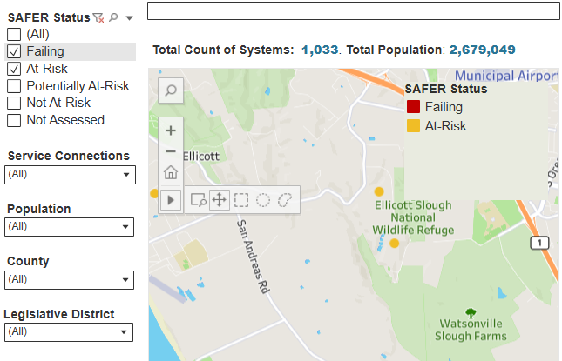
      - Select the adequate box if you identified if there is any drinking water system that is Failing or At-Risk of failure.
      - Click on the systems Failing and At-Risk and write down their names. Hover the mouse on top of the yellow and red circles that identify systems At-Risk and Failing respectively, and a window will come up with the name of the water systems, among other information. Write the name(s) of the systems Failing and At-risk in your self-assessment. You can download the entire list of systems failing, at-risk and others in this link.
      - In the webpage of the SAFER Dashboard, on the horizontal top menu, Click on the “Drinking Water” right next to Home, and then click on the “Field Operations Branch”: “The Field Operations Branches (FOB) are responsible for enforcing the federal and California Safe Drinking Water Acts (SDWAs) and overseeing about 7,500 public water systems.” Click on the “Field Operation Branches map and Contact Information” (If the previous doesn’t work use this link). You can get the information of the district associated with Your Water System. Pro-tip. Download the pdf file and right click on top of the District title with blue text, and then select “Copy email address”, that’s how you can get the email information of your district office.
      - Identify the different funding opportunities for the failing and at-risk water systems in the Funding Opportunities for Public Water Systems webpage of the SWRCB.

Endangered Species Act (ESA) and California Endangered Species Act (CESA)
      - Go to the California’s Threatened and Endangered Species webpage of the California Department of Fish and Wildlife, and take a look at the Threatened or Endangered Animal Species and Plant Species lists for California. In the Animal Species list (link here), focus on the Fishes and Amphibian section and identify in the common name if there is an animal species in the region where your water systems is located. For example, in the case of Pajaro Valley I looked for “Central Coast” species by doing a “Ctrl+F” and the “central” and a couple of species came up. Look for yours!

Policies that apply according to the water source

Surface Water Sources
      - You will use your response of Module 1 Q. 34. “Link of the search”. Click on the link of that search and you will have all the water rights in Your Water System. The eWRIMS webpage with your results should open. On the left menu, right next to “Point of Diversions” there is an icon to use the drop down menu for selecting “Export to Excel”. See figure below. Export your results to Excel.
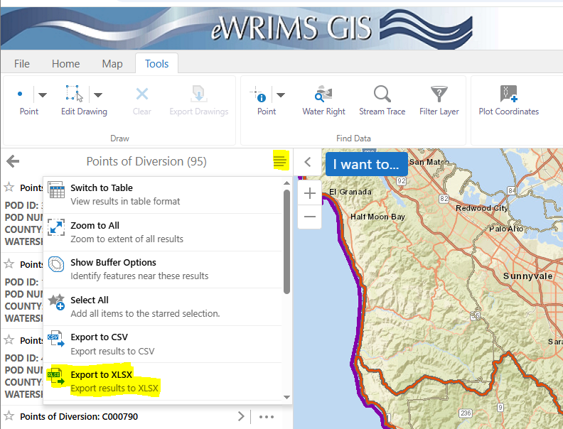
Open your excel file, and select the first row, then in the upper menu select “Data” “Filter” and you will have a filter tool in your excel file. This video also shows how to create a filter in the first row.
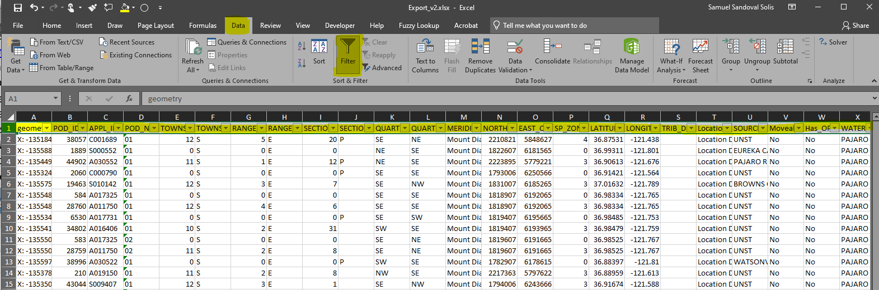
Go to column AR “WR_Type” that means Water Right Typeand select only “Statement of Div and Use”, this will select only the riparian water users
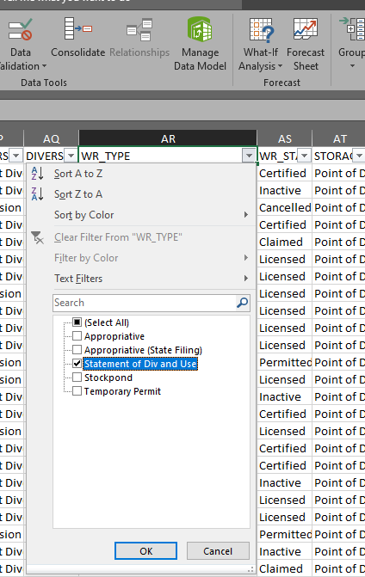
Now you can select the cells in Column AR and in the bottom of the window excel will count how many cell are selected. You can use this as the number of riparian water rights in Your Water Systems
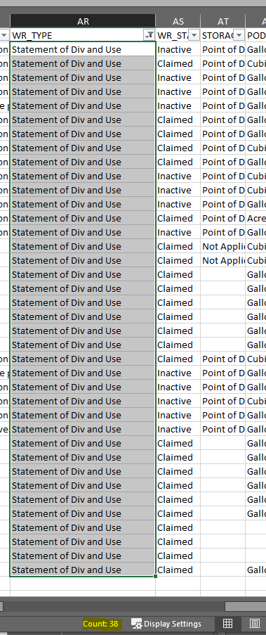
      - From Column AW, you can select the names of three riparian water right holders
      - Once again, from column AR “WR_TYPE”, use the filter to select only “Appropriative”. In column AS select those that are licensed and permitted. Then similarly, select column AR and in the bottom of the window excel will count how many cells are selected. You can use this number to count the number of water right appropriators are in Your Water System.
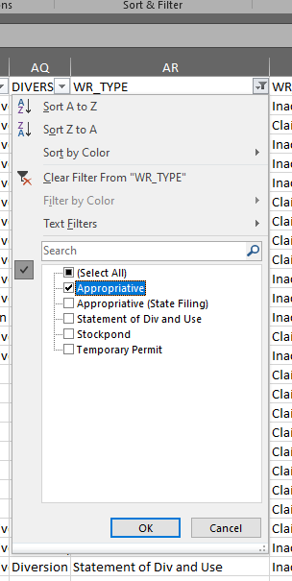 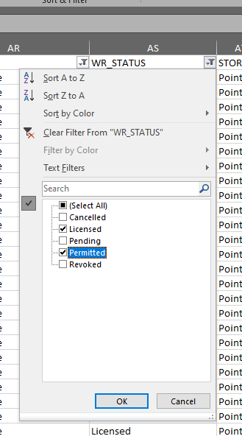 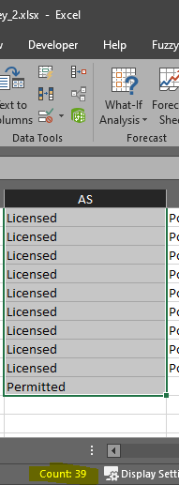
      - From Column AW, you can select the names of three appropriative water right holders

Groundwater sources
      - Go to the SGMA Data Viewer, on the left categories menu select “Reference Layers” and select the most recent Bulletin 118 Groundwater Basins layer. Get a screenshot of the map with your groundwater basins.
      - Use the sigma viewer and click on top of the polygons of the groundwater basin. In will appear a window at the bottom showing the names of the groundwater basins. Write them down in your self-assessment.
      - Copy and paste the figure that you have in Module 1 Question 36 that shows the map of the wells located in Your Water System.
      - Copy and paste the figure that you have in Module 1 Question 37 that shows the map of the wells supplying water to Public and State Small Water Systems
      - Read your guidebook Module 2 question “What is an overlaying groundwater right?” and respond accordingly.
      - This is a more difficult question. If your waters system is located in the counties of Shasta, Tehama, Butte, Glenn, Colusa, Sutter, Yolo, Sacramento, Yuba and Solano, then you have to look into this resource document and contact the person/website listed to see if there is an appropriative groundwater right holder.
      - Go to the SGMA Data Viewer, on the left categories menu select “Reference Layers” and select “Adjudicated Areas”. Get a screenshot of the map with your groundwater basins. Identify if Your Water System is located in an adjudicated area.
      - If Your Water System is located in an adjudicated area, write down its name, otherwise write down “Not Applicable”
      - Go to the SGMA Data Viewer, on the left categories menu select “Reference Layers” and select “Groundwater Sustainability Areas”, and “Approved Alternative Plans”. These plans are the areas managed by SGMA.
Also, there are agencies that have been working towards sustainable groundwater management plan before the passing of SGMA and they have submitted Alternative Plans. In the SGMA Data Viewer, “Reference Layers” select
If your water system is located in an alternative also mark “X” on the “Alternative Plan” column, if not, then write “N/A”
      - In the SGMA Data Viewer, once you are selected the layers from the previous step, click on top of the groundwater basin polygon(s) where Your Water Systems is located and write down the name of groundwater basin shown in the field of “Basin_Subbasin_Name”.
      - If you responded:
“No” in the previous question, then Your Water System is not managed by SGMA write down “N/A”.
Otherwise, go to the. If you responded only
“Yes” then go to the SGMA portal, in the upper menu select “GSP / Plans / All Submitted”, then look on the list and select the groundwater basin that you wrote in the previous question. Click on that your groundwater basin(s). From the information in the section of “GSP INITIAL NOTIFICATIONS” and “NOTICE OF THE PUBLIC HEARING” you can figure out the of the Groundwater Sustainability Agencies (GSAs) for your water systems. Write them down.
“Yes – Alternative Plan” then go to the SGMA portal, in the upper menu select “Alternative / All Submitted”, then look on the list and select the groundwater basin that you wrote in the previous question. Click on your groundwater basin. Write down the submitting agency.
      - From the webpage results of the previous step, your can access the information on this section. If the GSA submitted and alternative plan, then look for the “BMP – Basin Management Plan”.

Water for the Environment - Instream Flows
      - Go to the Existing Flow Requirements of the SWRCB and take a screen shot of the map showing the river that already have instream flows in the state of California.
      - Based on the map of the Existing Flow Requirements from the previous question, determine if there is an instream flow requirement already established in your water system.
      - If your answer was not to the previous question, then write “”N/A”. If your answer is yes, then in the Existing Flow Requirements webpage click on the reach segment(s) that passes through Your Water System, a pop up window come, click on the right arrow, another pop up window should appear, then copy and past the name of the existing flow requirement provided there.
      - Now, let’s take a look if CDFW (California Department of Fish and Wildlife) have determined a recommended flow criteria or study in the region of Your Water System. Click in the Flow Criteria Map website of CDFW and identify if there is flow criteria or a study in Your Water System. Select Yes or No.
      - If the previous question was Yes, then go to the Flow Criteria Map and click on the watershed(s) that has the study and write its name and get the link of the study.
      - Now, let’s take a look at the Natural Flows Database that provide instream flow recommendations for every river in California! Click on Explore data. In this database you will find recommended instream flows for every stream in California, so I am pretty confident that your will find recommended flow criteria for Your Water System. Please respond accordingly.
      - For this section you only need to download the recommended streamflows for one river reach. These recommended instream flows are based on the Functional Flows Approach, watch this video. First, zoom into the location of Your Water System, and click in the main river of your system. A window will pop up, you can keep the flow component of change it in the “Flow Component” drop down menu. You can copy from here the metric and value requested in this question (e.g. Dry-season baseflow, 8.18 cfs). To download the file you need to click in the “ + “ icon in the bottom right corner. This segment will be added in the upper box called “Streams”. Then click in “Download FFM Data” and you will have the list of Functional Flows that can be recommended as instream flows for the main river of Your Water System.
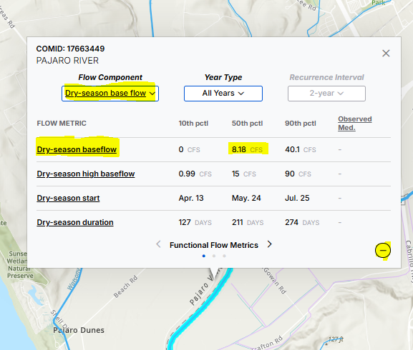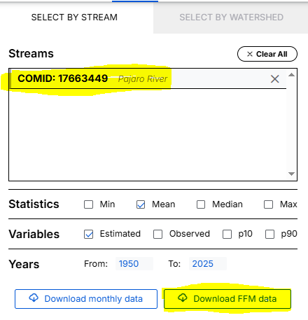

Tribal Water
      - You can copy the response from Module 1 Q.9. Also, you can identify if there is a reservation in the SGMA Data Viewer, on the left categories menu select “Reference Layers” in the section of “Political” select “Tribal Land Area Representation”. Alternatively, the California Water Policy Map show the tribal land in Yellow.
      - If there is a tribe, then there should be Federally Reserved Rights for that tribe. If there is no tribe then the answer is No.

Recycled Water
      - Go to the Volumetric Annual Report of Wastewater and Recycled Water webpage of the SWRCB. There is an interactive map where you can zoom in and identify if there is a Recycle Water facility in Your Water System. Based on the previous map respond if there is a recycled facility in Your Water System.
      - If there is a recycled water in Your Water System, then hover your mouse on top of it and the name of the recycle water facility should appear. Write it down. There are three categories of recycled facilities: Recycle Water Producers (RWP) that do not receive raw wastewater, Wastewater Treatment Plants (WWTP), and Waste Water Treatment Plants that produce Recycled Water (WWTP RW). Write down the category of the recycle water facility of your water system. Finally, take a screenshot of the map and paste the figure in your self-assessment.
Congratulations! You have completed Module 2 of 3!

Module 3: Writing a public comment letter for your water system

 | Response |  |  |  |  |  |  |  | Notes or specific information
Selecting a Public Comment Topic
- What issue do you plan to address?
- What sector is your public letter focused on? | Domestic | Municipal |  |  |  | Agriculture |  | Power Gen |  |  | Recreation |  | Navigation | Environ.
- What sector is your public letter focused on? | [ ] | [ ] |  |  |  | [ ] |  | [ ] |  |  | [ ] |  | [ ] | [ ]
- List the major policies involved:  See the California Water Policy Map | Policies Met  at All Times:
 | Surface Water:
 | Groundwater
 | Environment:
 | Tribal Water:
 | Recycled Water
- What agencies are involved with this issue?
Intervening in a Public Comment Process
- Identify the process type for your comment: | Administrative |  |  |  |  |  |  |  |  | Legislative
- Identify the process type for your comment: | [ ] |  |  |  |  |  |  |  |  | [ ]
- Identify a solicitation for a comment:
- Identify the comment period deadline:
- How will you submit the comment? | Mail |  |  |  |  |  | Email/Electronic |  |  |  |  | In-Person
- How will you submit the comment? | [ ] |  |  |  |  |  | [ ] |  |  |  |  | [ ]
- Are there public meetings scheduled? | Date(s): |  | MM/DD/YYYY
- Are there public meetings scheduled? | Time:
- Are there public meetings scheduled? | Location:
- Are there public meetings scheduled? | Zoom:
Locating Information for Comment Header
- Who will you address your comment to? | Name:
- Who will you address your comment to? | Phone Number:
- Who will you address your comment to? | Agency/Org.:
- Who will you address your comment to? | Title:
- Who will you address your comment to? | Address:
- Who will you address your comment to? | Email:
- (Optional): Title your comment.
Letter Paragraph 1: Opening, Position, and Context
- What is your position on the issue?
- Who is this letter about?
- Why are you writing this letter?
- What is the context? When and where?
- Is there a personal story you can share?
- What policy(ies) will you reference?
- Three pieces of data that illustrate the issue: | Data Point #1
- Three pieces of data that illustrate the issue: | Data Point #2
- Three pieces of data that illustrate the issue: | Data Point #3
Letter Paragraph 2: Supporting Information
- Why does it matter to you/your community? | Example #1
- Why does it matter to you/your community? | Example #2
- Is there data from Module 1 and Module 2 to support your argument and position? | Yes |  |  |  |  |  |  |  |  | No
 | [ ] |  |  |  |  |  |  |  |  | [ ]
- If yes, list data that supports your position | Data Point #1
- If yes, list data that supports your position | Data Point #2
- If yes, list data that supports your position | Data Point #3
Letter Paragraph 3: Call to Action
- What should the agency do about the issue?

- What are some ideas for fixing the problem?
- How do you want to see this issue solved?

Comment Template
- Complete the Comment Template | Your Name or Your Group’s Name  Your Address  Your City, CA Zip Code  email@somedomain.com  MM/DD/YYYY  Recipient Name  Name of City or County  Their Address  Their City, CA Zip Code  emailaddress [at] XXXXX [dot] com,  Re: TITLE OF COMMENT LETTER OR PROCESS  Dear NAME:  PARAGRAPH 1: Opening of Letter  I am writing this letter to highlight XXXXXXXXXXXXX as part of the XXXXXXX in the public comment process.  What is your position?  Who is this letter about?  Why are you writing this letter?  Where and when is this issue occurring?  Is there a personal story you can share?  ** Be sure to reference at least one policy and three pieces of data from Module 1 and Module 2 in the opening of your letter.  PARAGRAPH 2: Supporting Information  Why does this matter to you or your community?  Is there data that exists to support your argument on this?  PARAGRAPH 3: Call to Action  What should policymakers do about this issue?  What are some ideas for fixing the problem?  How do you want to see this issue solved to benefit everyone?  Sincerely,  Your Name/Affiliation Name Here

Congratulations! You have completed Module 3 of 3!

Instructions to fill the Module 3 section

Resources
For this module, you will use the knowledge and answers from the previous module, the California Water Policy Map, and your guidebooks to apply your knowledge in a public comment letter.

Selecting a Public Comment Topic
      - Review Module 1 and Module 2. Reflect on the information you collected and review key issues and challenges facing your water system. In the form, write a few sentences (2-3) on an issue you have an opinion on and would like to address with a policy agency (State Water Resources Control Board, Groundwater Sustainability Agency, etc.)
      - Check what sector or sectors the issue you identified falls under:
Domestic: Does the issue affect personal drinking water supplies?
Municipal: Does the issue affect city water supplies?
Agriculture: Does the issue affect agricultural interests?
Power Generation: Is the production of hydropower affected by this issue?
Recreation: Is recreation affected by this issue?
Navigation: Does the issue impair or affect navigation of waters?
Environmental: Are there ecological impacts from this issue?
      - From there, consider all of the specific policies involved in the issue. Consult Module 2 and the Water Policy Map, as needed. There will likely be multiple policies involved in any given issue, and you are encouraged to do additional research to search for policies that touch on other dimensions, such as public health. For instance, if you are looking at nitrate contamination in groundwater, a few policies you might list could include the Porter-Cologne Water Quality Control Act, the Sustainable Groundwater Management Act, the Human Right to Water, and also the Irrigated Lands Regulatory Program. Be as thorough and expansive as possible.
      - List all of the agencies responsible for overseeing these policies. You have likely identified many of these agencies in Module 2. Again, for this portion of the exercise, it is likely you will identify more than one agency.

Intervening in a Public Comment Process
      - In California and elsewhere, there are generally two types of processes where comments are received: administrative and legislative. In this part of the worksheet, you will identify which process you plan to participate in.
        - Administrative Process: Comments on administrative issues involve regulatory executive branch agencies. These agencies are responsible for executing and enforcing the law. They make rules and regulations, at the direction of the Legislature, or they decide on water rights and water management. These agencies include: the State Water Resources Control Board, the Department of Water Resources, local Groundwater Sustainable Agencies, local Irrigation Districts, Local Water Districts, or your county’s public health district. They often have rulemaking processes, where the public is invited to submit comments. Sometimes these agencies host hearings, playing a quasi-judicial role, where the public can also comment.
        - Legislative Process: These bodies are responsible for making the laws, and they include elected and appointed officials meant to represent local, regional, or statewide constituencies. The California Legislature is the most well-known legislative body, but your local City Council or the Board of Supervisors can serve legislative roles.
        - NOTE: In some cases, governmental bodies can take on multiple roles and wear multiple hats. Do not stress too much about how you answer this question. It is more to get you to think about what kind of process you are commenting on. Are you commenting on a process to enforce the law? Or a process to make the rules?
      - Here, you will identify the solicitation for public comment. How will you intervene in the process? To do this, you have to put on your research cap and poke around the websites of the agencies you listed in Question 4. Look at their meeting agendas, notices, and announcements. Are they actively working on the issue you’re focused on? Are there any processes in which they are accepting public comments? In addition to the local agency website, California lists all ongoing regulatory proceedings on the Office of Administrative Law. This could be another place to look. Here’s one example of what a rulemaking may look like

Once you have found a forum, solicitation or process to comment on (i.e., a public meeting, a hearing, or rulemaking), please put a link to that information in the form.

==== PUBLIC COMMENT AND HEARING ON REVISED DRAFT SACRAMENTO/DELTA UPDATES TO THE WATER QUALITY CONTROL PLAN FOR THE SAN FRANCISCO BAY/SACRAMENTO­SAN JOAQUIN DELTA WATERSHED ==== https://www.waterboards.ca.gov/bay_delta/bay_delta_plan/docs/notice-baydeltaplanupdates-07-2025-en.pdf

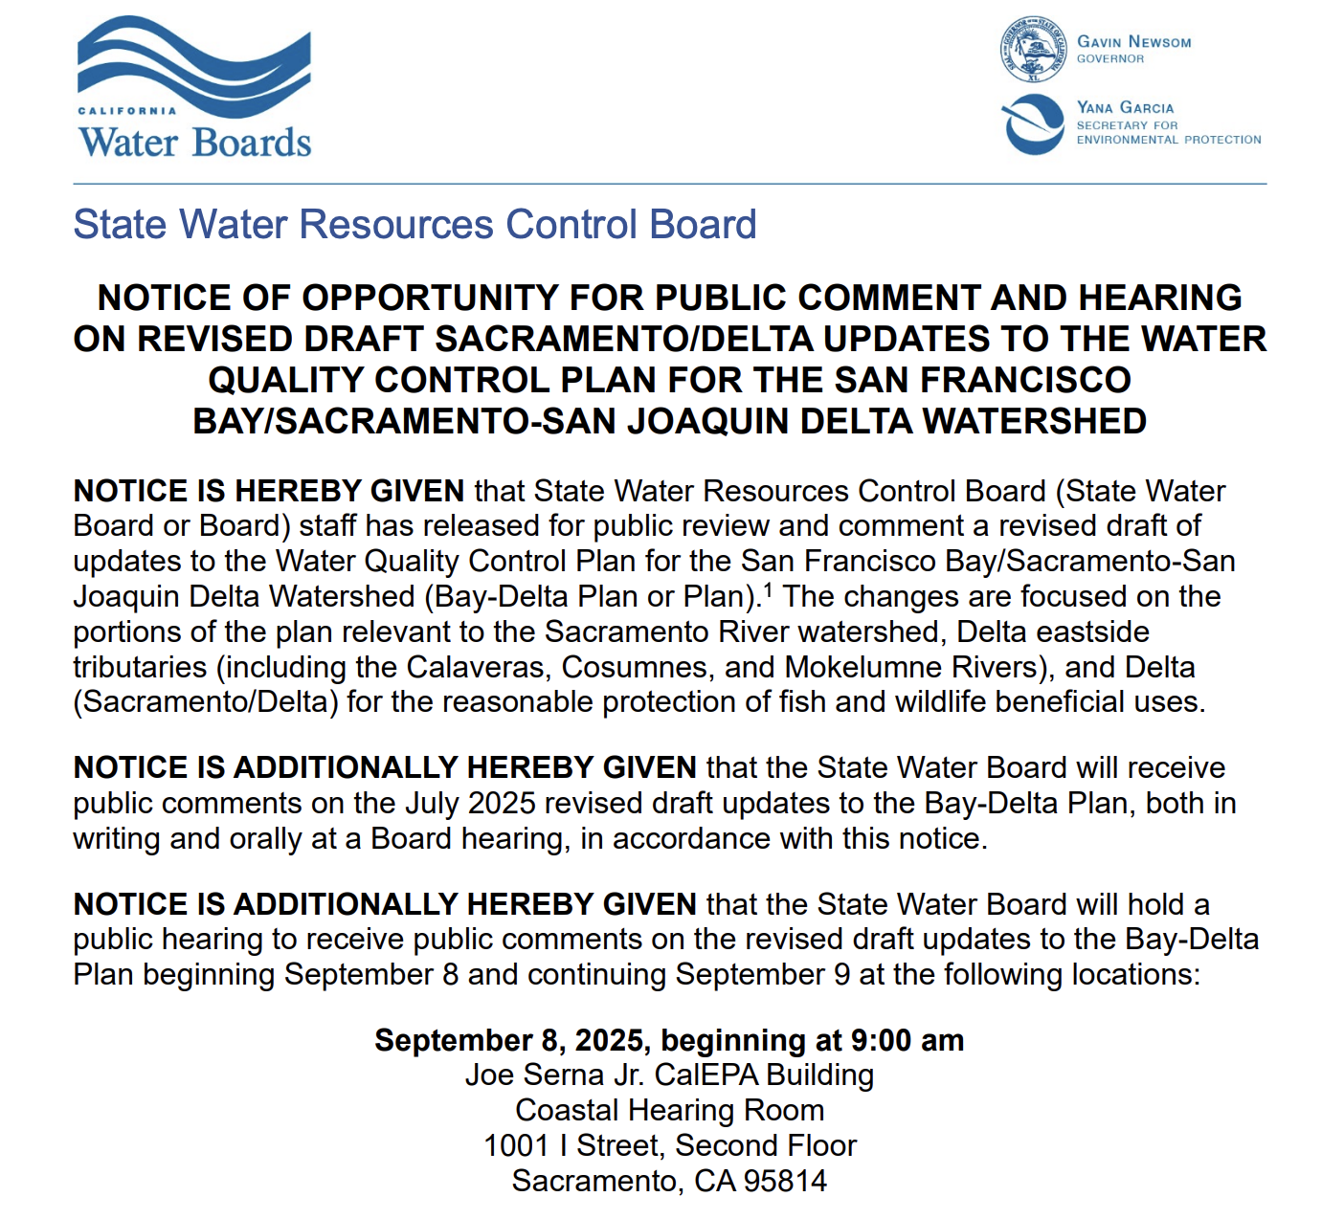

      - If the process includes any dates or deadlines for the comment period, include them here.
      - List how you will submit your comment letter. Most comment letters are delivered by mail, email or an electronic system. Comments can also be delivered in-person at public meetings. According to the Brown Act, California’s sunshine law, many governmental bodies with open meetings must provide a time for the public to comment on issues. In many cases, you need to send a request for speaking at these meetings, and they will allocate you around 3 minutes for your comment. Make sure you let the person organizing these meeting to know that you are requesting time, and they must assign you time for expressing your comment.
      - If a public meeting is scheduled, please include that information in the form.

Locating Information for a Public Comment
The following sections will focus on compiling the public comment letter. Before we get started, here are several resources that might be helpful in thinking about how to gather the information needed and format your public comment letter:

- Heal the Bay – How to Make Public Comments & Advocate for Clean Water
- Environmental Law Institute: Tips for Writing Effective Public Comments
- EJ Greenbook – Submitting Public Comments | Sample Public Comment Template
- California Dept. of Justice – Tips for Submitting Effective Public Comments

      - Identify the person or organization in charge of receiving public comments on the issue you are focused on. In some cases, you will be addressing a board of directors. In other cases, you may be addressing a program manager or the head, a legislative committee or an individual legislator. Use the link in Question 6 to research who to address your comment to. Fill in the Name, Phone Number, Agency/Org., Position Title (if applicable), Address and Email.
      - Optional: Not all comments require titles. But in some cases, titles can be useful to those receiving the comment so they can organize it and respond appropriately. An appropriate title can be as simple as “RE: NAME OF EVENT/PROCESS.” For example, “RE: HEARING ON REVISED DRAFT SACRAMENTO/DELTA UPDATES TO THE WATER QUALITY CONTROL PLAN”

Letter Paragraph 1: Opening, Position, and Context
      - Write 2-3 sentences outlining your position on the issue.
      - Write 2-3 sentences on who this letter is concerning. Does it involve you personally? Your organization? Your community? Use this as an opportunity to introduce yourself and your background.
      - In 2-3 sentences, condense why are you writing this letter?
      - Go through Module 1 and Module 2 to list any applicable context for the letter? When and where is the problem you’re focusing on occurring? Use this as an opportunity to introduce your water system and important details about it.
      - Is there a personal story you can share? In public comments, anecdotes or personal stories can provide persuasive details for regulators. If not, you can skip this question. But please try to think about what you might be able to include.
      - What policies do you plan to reference? Please be as specific as possible. Effective comment writing typically relies on good citations and references to policies. You want to provide regulators with pathways to take action. See this example from the Environmental Law Institute about the importance of including specific references to policies.
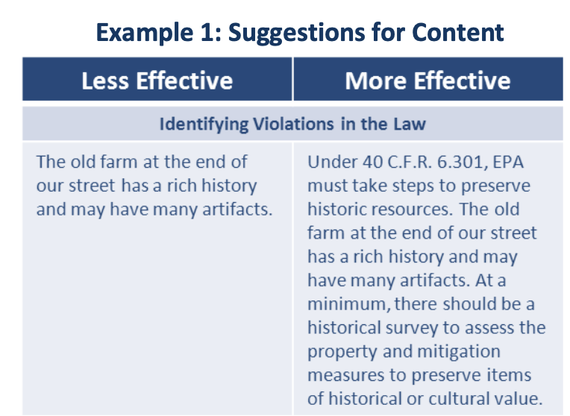
      - Expanding on Question 15, identify three data points you want to emphasize and best illustrate the issue at hand.

Letter Paragraph 2: Supporting Information
      - Provide two examples of why this issue matters to you and your community.
      - Is there data from Module 1 and Module 2 to support your argument and position?
      - If yes, provide three concrete data points.

Letter Paragraph 3: Call to Action
      - In 2-3 sentences, what should the agency do about this issue?
      - In 2-3 sentences, what are some of your ideas for fixing the problem?
      - How do you want to see this issue solved? Effective comments often end with a strong but respectful call to action.
See again the Environmental Law Institute Example for more on this.
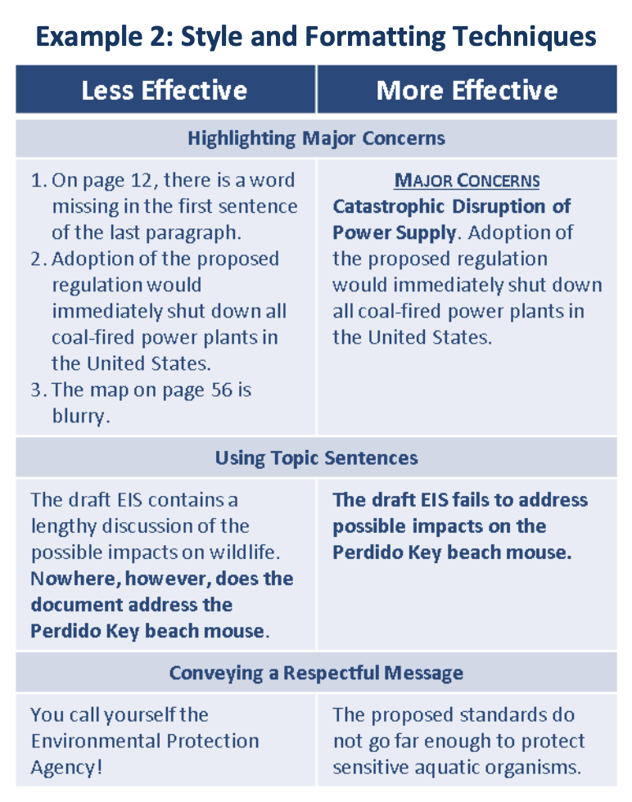

Comment Template
      - Bring it all together! Use your answers in Questions 10-24 to write your own public comment.

Congratulations! You have completed Module 3 of 3!

