ESM 121

Water Science

and Management

Exercise 6:

Simulation Modeling

and

Optimization Modeling



Samuel Sandoval Solis, PhD

**Table of Contents**

Simulation Modeling 3

River system 3

Water Resources Performance Criteria 19

River and Reservoir System 31

Optimization Modeling 36

Objective 36

Steps for Linear Programming 37

Exercise 1 (Adapted from McKinney). 39

Exercise 2 (Adapted from Loucks and van Beek) 58

Exercise 3 The perfect outfit! Extra credits (+20%) 59

Exercise 4 (Adapted from Loucks and van Beek) Extra credits (+20%) 61

# Simulation Modeling

The aim of this exercise section is to explore basic concepts of operating and allocation policies. Using the water available for each user, you will define equations that allocate water for the river and among 3 users.

## River system

The water system is shown in Figure 1. There are 4 main water demands with different water requirements and priorities (Table 1).

|  |  |  |  |  |
| --- | --- | --- | --- | --- |
| Water Demands | | | | |
| Priority | 1 | 3 | 3 | 2 |
| Name | River | User 1 | User 2 | User 3 |
| Nickname | (Qt) | (X1t) | (X2t) | (X3t) |
| Volume | 2 | 2.5 | 3 | 5 |

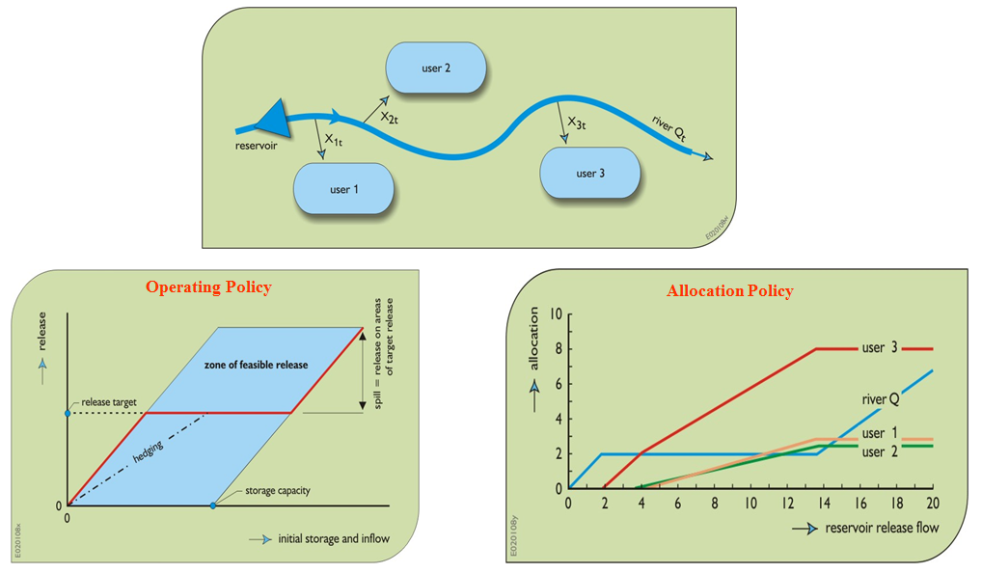

**Qtin**

Figure 1

This is description of the water allocation policy for the system shown in Figure 1.

* *River* has the first priority, at least 2 units of water should be left in the river (if available) before the rest of the users can take their water demand. Once the water demand of all the user have been supplied, if there is any water available, then the remaining water will be left in the river.
* *User 3* has the second priority, and once the *River* has met its demand, then *User 3* will take as much water up to meet its water demand, which is 5 units.
* *User 1* and *User 2* share both the 3rd priority in the system. Once *River* and *User 3* have met their water demands, then *User 1* and *User 2* will take as much water as they can in the same proportion up to their water demand is fulfilled, *User 1* = 2.5 units of water and *User 2* = 3 units of water.

To solve this exercise of water operation and allocation policy; first, you will estimate the allocation policy (Step 1), and second, you will *copy and paste* the formulas OR *lookup* this allocation policy when you are running the calculations (Step 2).

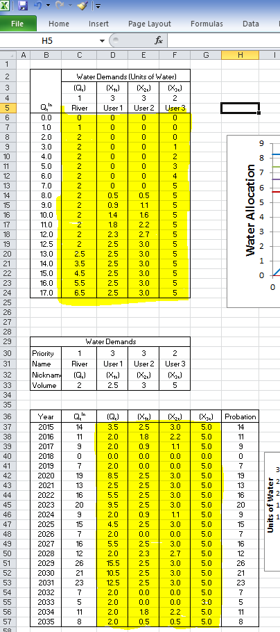

**Step 2**

**Step 1**

Figure 2. Step 1, water allocation policy and Step 2, mass balance model.

### Defining the water allocation policies.

#### Water User: River

First, let’s start working with *River*. According to the description provided by the allocation policy, water is left in the *River* using the following instructions:

“*River”* has the first priority, at least 2 units of water should be left in the river (if available) before the rest of the users can take their water demand. Once the water demand of all the user have been supplied, if there is any water available, then the remaining water will be left in the river.”

This can be converted into equations as follow:

$$Q_{t}^{River}=\left\{\begin{matrix}Q_{t}^{in} & if & Q_{t}^{in}<2 \\ Q_{t}^{in}-\sum_{i=1}^{1=3}{X_{i t} } & if & Q_{t}^{in}>2+\sum_{i=1}^{1=3}{X_{i t} } \\ 2 & if & Q_{t}^{in}>2 and Q_{t}^{in}<2+\sum_{i=1}^{1=3}{X_{i t} }\end{matrix}\right.$$

The first condition, *QtRiver* = *Qtin*, refers to “*River* [..], at least 2 units of water should be left in the river (if available)”, the second condition, *QtRiver* = 2, refers to “*River* [..], at least 2 units of water should be left in the river (if available)” and the third condition, *QtRiver* = , refers to “Once the water demand of all the user have been supplied [$2+\sum_{i=1}^{1=3}{X_{i t} }$], if there is any water available, then the remaining water will be left in the river.”

Before declaring these equations, it will be easier if we define names to the variables first. Go to cell C54. Then, go to the menu of Formulas and click on “Define Name”. A dialogue window should come out, you should name the variable “River_WD” as a short name of “River Water Demand”. ”. Very important, make sure that in “Scope:” drop down menu you select “**Part 2 - River**”. By default the “Refers to:” section should be selecting the cell C54 where the cursor is located. If this is not showing, click on the “cells and arrow” icon on the right and select the cell C54. By doing this, you are naming that cell “River_WD” that you will be able to call it like that in excel, cool, isn’t it!

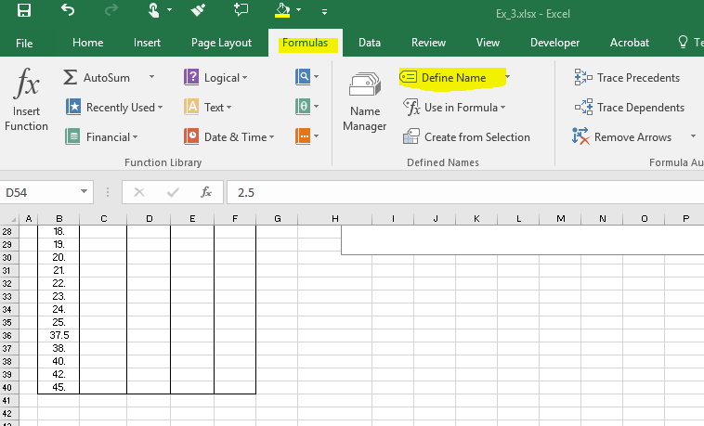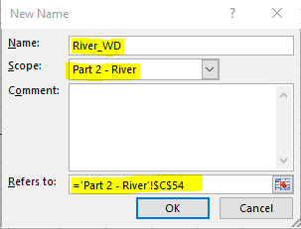

You will have to “Define Name” for the following variables and cells:

|  |  |
| --- | --- |
| **“Define Name” Variable** | **Cell** |
| River_WD | C54 |
| X1_WD | D54 |
| X2_WD | E54 |
| X3_WD | F54 |

If you had a problem naming your variables or not selecting the right cell, you can click on the Formulas/Name Manager where you can delete or edit you variables

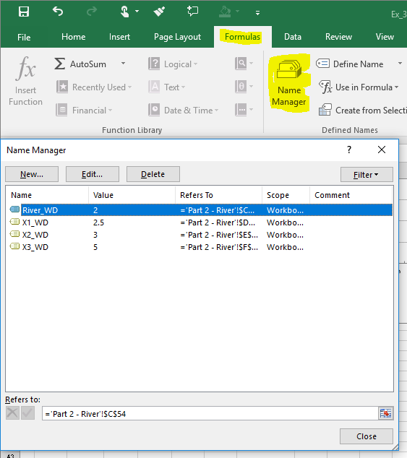

Now, lets go to Cell C6 and type the following equation:

The equation in Cell C6 is: “=IF(B6<=River_WD,B6,IF(B6>River_WD+SUM(X1_WD,X2_WD,X3_WD),B6-SUM(X1_WD,X2_WD,X3_WD), River_WD))”

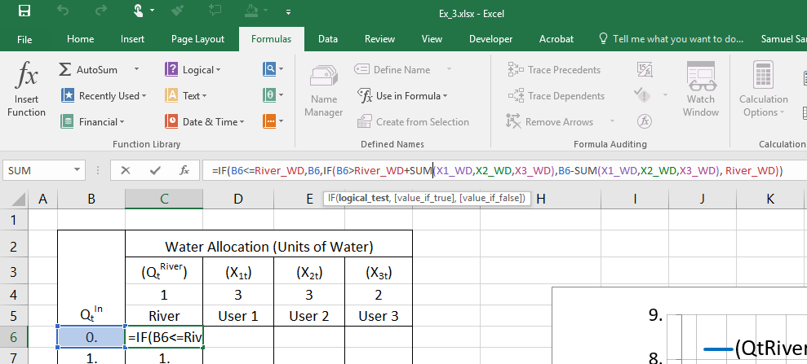 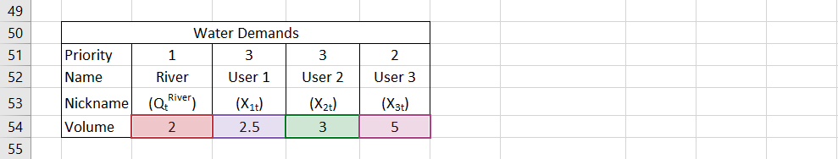

Figure 3

The first part of this equation, grey box, refers to the first condition, the green box refers to the third condition, and if none of the previous conditions applied, then it applies the result from condition 2.



$River_{t}=\left\{\begin{matrix}Q_{t}^{in} & if & Q_{t}^{in}<2 \\ 2 & if & Q_{t}^{in}>2 and Q_{t}^{in}<2+\sum_{i=1}^{1=3}{X_{i t} } \\ Q_{t}^{in}-\sum_{i=1}^{1=3}{X_{i t} } & if & Q_{t}^{in}>2+\sum_{i=1}^{1=3}{X_{i t} }\end{matrix}\right.$

Figure 4

Copy and paste this equation for the remaining of the column.

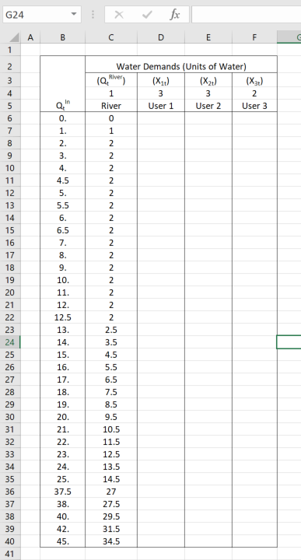  
Figure 5

#### Water User: User 3

According to the description provided by the allocation policy, *User 3* has the second priority, and once the *River* has met its demand, then *User 3* will take as much water up to its water demand is fulfilled, which is 5 units.

This can be converted into equations as follow:

$$X_{3t}=\left\{\begin{matrix}0 & if & Q_{t}^{in}≤2 \\ Q_{t}^{in}-Q_{t}^{River} & if & Q_{t}^{in}>Q_{t}^{River} and Q_{t}^{in}<Q_{t}^{River}+X_{3t} \\ 5 & if & Q_{t}^{in}≥Q_{t}^{River}+X_{3t}\end{matrix}\right.$$

The first condition, *X3t*=*0*, refers to “*User 3* has the second priority, and once the *River* has met its demand, then *User 3* […];” the second condition, *X3t=5*, refers to “*User 3* [..] will take as much water up to meet its water demand, which is 5 units.” and the third condition, *X3t=Qtin-QtRiver* refers to “*User 3* […] will take as much water up to its water demand is fulfilled, which is 5 units.”

The equation in Cell F6 is: “=IF(B6<=River_WD,0,IF(AND(B6>River_WD,B6<River_WD+X3_WD),B6-River_WD,X3_WD))”

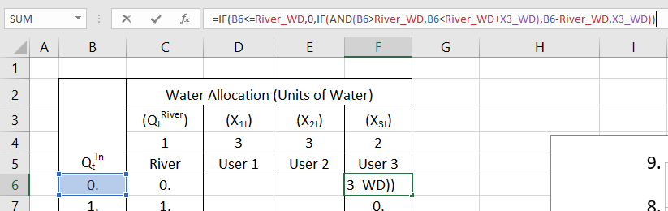  
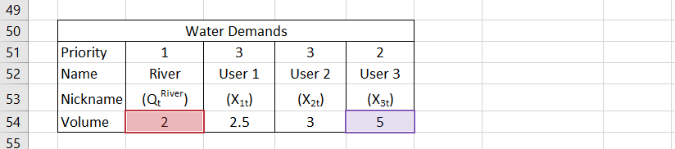  
Figure 6

The first part of this equation, grey box, refers to the first condition, the green box refers to the third condition, and if none of the previous conditions applied, then it applies the result from condition 2.



$X_{3t}=\left\{\begin{matrix}0 & if & Q_{t}^{in}≤2 \\ 5 & if & Q_{t}^{in}≥Q_{t}^{River}+X_{3t} \\ Q_{t}^{in}-Q_{t}^{River} & if & Q_{t}^{in}>Q_{t}^{River} and Q_{t}^{in}<Q_{t}^{River}+X_{3t}\end{matrix}\right.$

Figure 7

Copy and paste this equation for the remaining of the column.

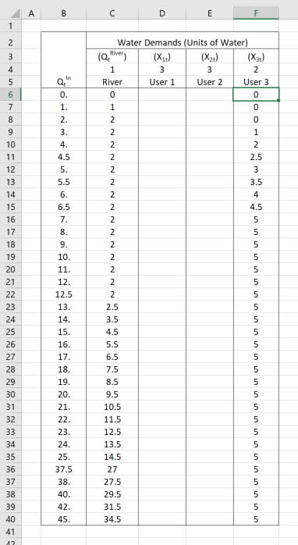  
Figure 8

#### Water User: User 1 and 2

According to the description provided by the allocation policy, *User 1* and *User 2* share both the 3rd priority in the system. Once *River* and *User 3* have met their water demands, then *User 1* and *User 2* will take as much water as they can in the same proportion up to meet their water demand, *User 1* = 2.5 units of water and *User 2* = 3 units of water.

For *User 1*, this can be converted into equations as follow:

$$X_{1t}=\left\{\begin{matrix}0 & if & Q_{t}^{in}≤Q_{t}^{River}+X_{3t} \\ \left(Q_{t}^{in}-\left(Q_{t}^{River}+X_{3t}\right)\right)×\left(\frac{X_{2t}}{X_{1t}+X_{2t}}\right) & if & Q_{t}^{in}-\left(Q_{t}^{River}+X_{3t}\right)<X_{1t}+X_{2t} and Q_{t}^{in}>Q_{t}^{River}+X_{3t} \\ 2.5 & if & Q_{t}^{in}-\left(Q_{t}^{River}+X_{3t}\right)>X_{1t}+X_{2t} \end{matrix}\right.$$

For User2, this description can be converted unto equations as follows:

$$X_{2t}=\left\{\begin{matrix}0 & if & Q_{t}^{in}≤Q_{t}^{River}+X_{3t} \\ \left(Q_{t}^{in}-\left(Q_{t}^{River}+X_{3t}\right)\right)×\left(\frac{X_{1t}}{X_{1t}+X_{2t}}\right) & if & Q_{t}^{in}-\left(Q_{t}^{River}+X_{3t}\right)<X_{1t}+X_{2t} and Q_{t}^{in}>Q_{t}^{River}+X_{3t} \\ 3 & if & Q_{t}^{in}-\left(Q_{t}^{River}+X_{3t}\right)>X_{1t}+X_{2t}\end{matrix}\right.$$

The first condition, *X1t*=*0*, refers to “Once *River* and *User 3* have met their water demands, then *User 1* and *User 2* will take […];” the second condition, *X1t=2.5*, refers to “[…] *User 1* and *User 2* will take as much water as they can in the same proportion up to meet their water demand, *User 1* = 2.5 units of water and *User 2* = 3 units of water” and the third condition, refers to “[…] *User 1* and *User 2* will take as much water as they can in the same proportion up to meet their water demand, *User 1* = 2.5 units of water and *User 2* = 3 units of water”

The equation for *User 1* in Cell D6 is: “=IF(B6<=River_WD+X3_WD,0,IF(B6-(River_WD+X3_WD)>=X1_WD+X2_WD,**X1_WD**,(B6-(River_WD+X3_WD))*(**X1_WD**/(X1_WD+X2_WD))))”

  
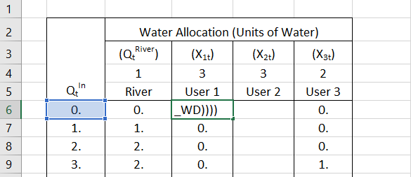  
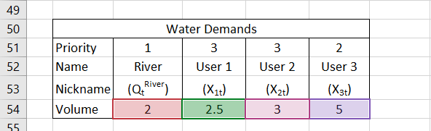  
Figure 9

The first part of this equation, grey box, refers to the first condition, the green box refers to the third condition, and if none of the previous conditions applied, then it applies the result from condition 2.



$$X_{1t}=\left\{\begin{matrix}0 & if & Q_{t}^{in}≤Q_{t}^{River}+X_{3t} \\ 2.5 & if & Q_{t}^{in}-\left(Q_{t}^{River}+X_{3t}\right)>X_{1t}+X_{2t} \\ \left(Q_{t}^{in}-\left(Q_{t}^{River}+X_{3t}\right)\right)×\left(\frac{X_{2t}}{X_{1t}+X_{2t}}\right) & if & Q_{t}^{in}-\left(Q_{t}^{River}+X_{3t}\right)<X_{1t}+X_{2t} and Q_{t}^{in}>Q_{t}^{River}+X_{3t} \end{matrix}\right.$$

The equation for *User 2* is very similar to *User 1*, in Cell E6 is: “=IF(B6<=River_WD+X3_WD,0,IF(B6-(River_WD+X3_WD)>=X1_WD+X2_WD,**X2_WD**,(B6-(River_WD+X3_WD))*(**X2_WD**/(X1_WD+X2_WD))))”

Copy and paste this equation for the remaining of the column.

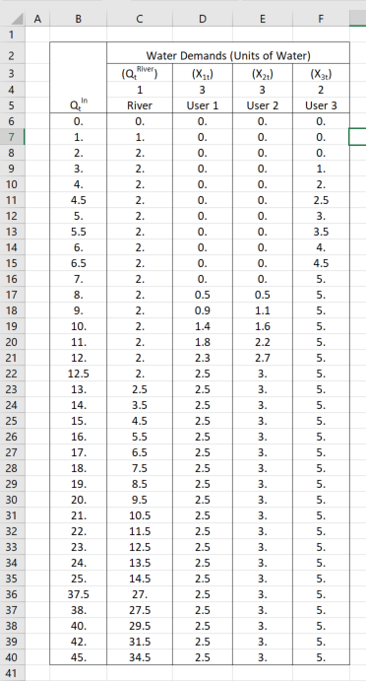  
Figure 10

The graph should look like:

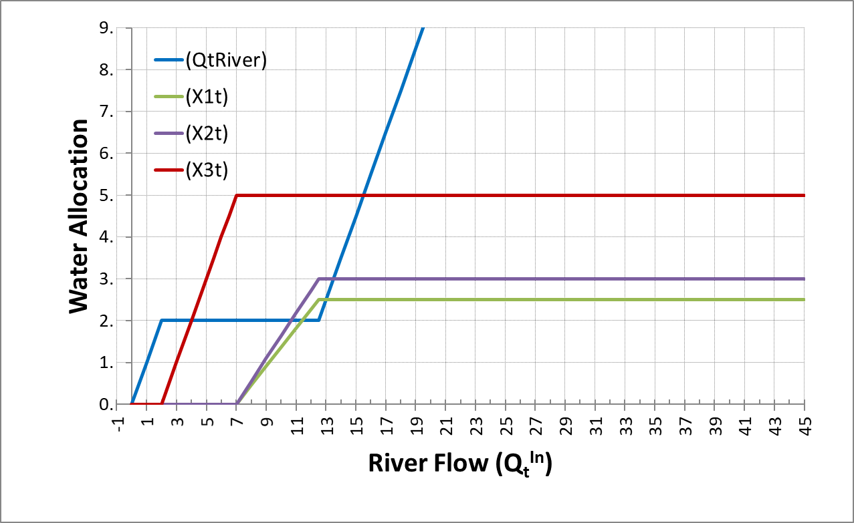  
Figure 11

### Linking the Water Allocation policy with the Mass Balance Model

There are two methods to use the allocation policy that was just derived into the *mass balance model*. Use **EITHER** of the following two methods, **but only chose one**, the one that you feel more comfortable using.

#### First Method

The easiest way is to select cells C6 to F6 (C6:F6), copy (CTrl+C) and paste the formulas on cells into cells D45 to G45 (D45:G45).

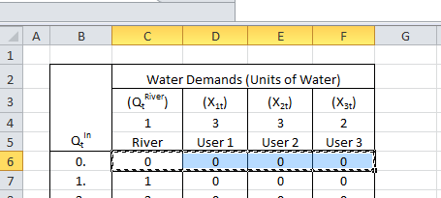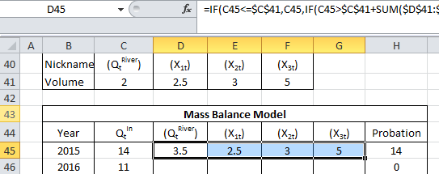  
Figure 12. On the left, Copy (Ctrl+C) cells C6 to F6, and paste them (Ctrl+V) into cells D45 to G45

And then use these cells (D45:G45) to copy then through the rest of the table.

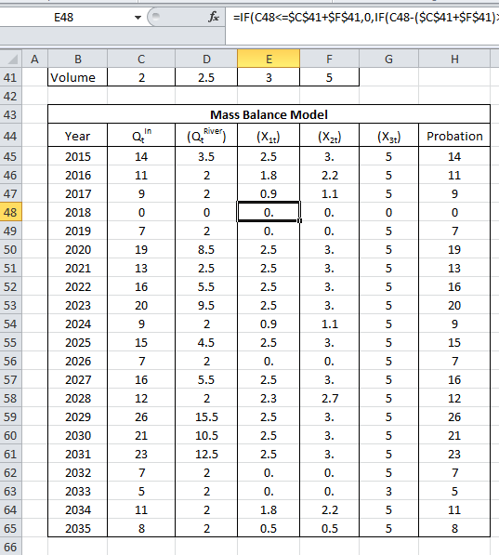  
Figure 13

#### Second Method

The second way to do this, is a little bit more elegant, but still the same principle. This method is used, and it is very helpful, when managing large amount of water users. In this case, what you want is to have control of the water allocating policy in one table (B6:F40) and to recall values from this table in the mass balance model (B59:H79). You can create a “lookup” command that will find the values estimated in the allocation policy table. In cell D59, let’s insert a command that will look up for the value of *QtRiver* in the table water allocation table using the following equation:

“=VLOOKUP($C59,$B$6:$F$40,2,TRUE)”

What the previous command means, is that excel will lookup vertically (“VLookup”) for the Qtin value of cell C59 (in this case 14) in the first column (it always start looking in the first column) of the table specified by the cell coordinates “$B$6:$F$40” (the green box in the following figure), and it will retrieve the value of column number 2 of the specified table, which is *QtRiver*, in this case for 14 is 3.5. When using this command, make sure to specify the column number that you want values to retrieve, and excel will always use the first column as the column to lookup for numbers, in this case, it will look for the “approximate” value in cell C58 on the first column of the table specified, that’s why at the end of the command you need to write “TRUE”.

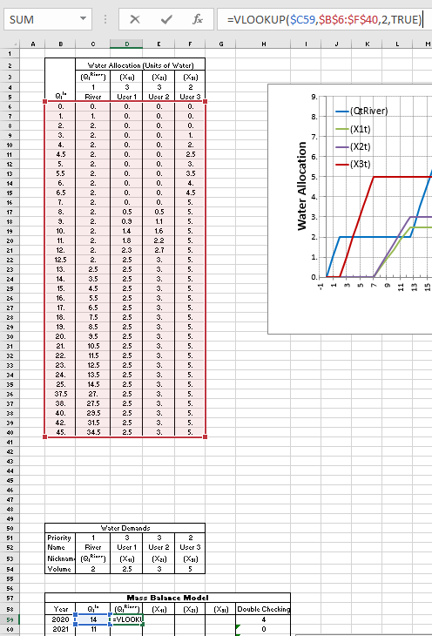  
Figure 14

For *User 1*, *X1t*, use the following equation in cell E59: “=VLOOKUP($C59,$B$6:$F$40,**3**,TRUE)”

For *User 2*, *X2t*, use the following equation in cell F59: “=VLOOKUP($C59,$B$6:$F$40,**4**,TRUE)”

For *User 3*, *X3t*, use the following equation in cell G59: “=VLOOKUP($C59,$B$6:$F$40,**5**,TRUE)”

Results from the Mass Balance model should look like the following pictures

  
Figure 15

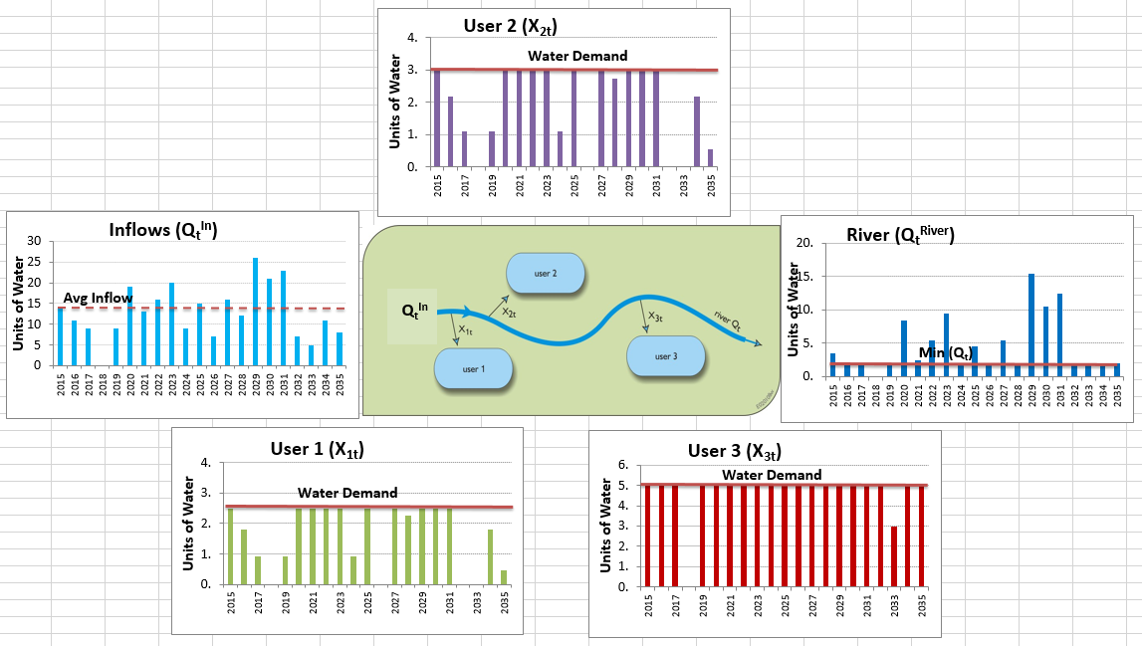  
Figure 16

### To be turned in:

1. Show a table like the one calculated in Figure 15 and the series of graphs calculated in Figure 16.

## Water Resources Performance Criteria

Phew, we have done a lot of work to describe the water allocation system for four water demands (River, X1, X2, and X3), imagine in a basin where we have hundreds and sometimes thousands of users! All the previous work quantitatively describes how water is allocated, but it does not gives us any performance of the water supply. For estimating the water supply performance, there are four water resources performance criteria used widely in the field: Reliability (in time and volume), Vulnerability, and Resilience. I will show you how to calculate those water resources performance criteria to evaluate the our water resources system.

### Reliability (Time and Volume)

Have you ever heard in the news about “Water Supply Reliability”? do you remember Governor Brown in our last drought when he talked about “making sure everyone had a reliable water supply during the drought? Water Supply *Reliability* is a common term used to quantify how frequent a water demand is met (time-based reliability), and how close to the total amount demanded (volumetric reliability). The *time based reliability* is the portion of time that water demand is fully supplied, or in other words, how frequent a water demand is fully supplied.

To estimate the time based reliability, we need to estimate *water supply deficits*, which is the difference between the water demand minus the water supplied:

$${Deficit}_{t}^{i}=\left\{\begin{aligned}X_{Demand,t}^{i}-X_{Supplied,t}^{i} if X_{Demand,t}^{i}>X_{Supplied,t}^{i} \\ 0 if X_{Demand}^{i}=X_{Supplied,t}^{i}\end{aligned}\right.$$

where: *XiDemand,t* is the water demand for the *i*th water user, and *XiSupplied,t* is the water supplied in the *t*th time period. Finally, the reliability for the *i*th user is:

$${Reliability(time)}^{i}=\frac{\# of times {Deficit}_{t}^{i}=0}{n}$$

where *n* is the total number of time steps, often used the total number of years or months, depending on the water management unit of time.

The volumetric reliability is the sum of the deficits divided by sum of the water demand. The volumetric reliability express how much water was supplied compared with the total amount of water demanded.

$${Reliability(volume)}^{i}=\frac{\sum{X_{Supplied,t}^{i}}}{\sum{X_{Demand,t}^{i}}}$$

First, let’s calculate the matrix of Water Supply Deficits. As mentioned before, a water supply deficit is the difference between the water demand minus the water supplied. For the River demand, a deficit only exist if the water supplied is less than the water demand ($Q_{t}^{River}$ = 2 units of water). Let’s estimate the deficit for year 2020 in cell D87 as follows: “=IF(D59<River_WD,River_WD-D59,0)”

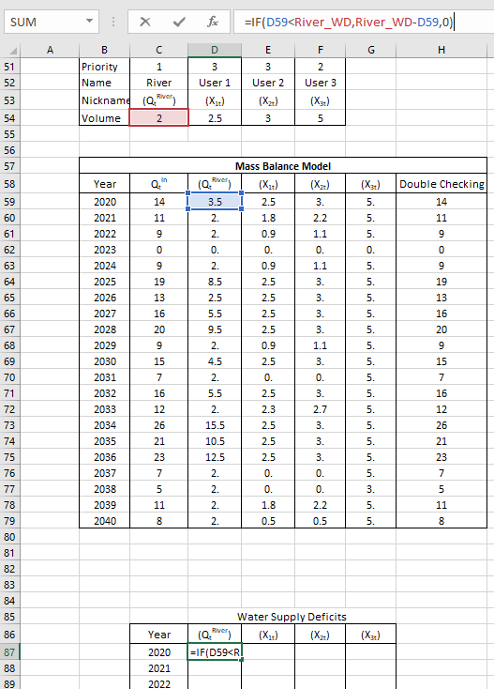

If you copy and paste the equation of cell D87 in cells D88:D107, you will realize that only one year (2023) the river was not able to meet it’s water demand of 2 units of water, with a deficit of two units.

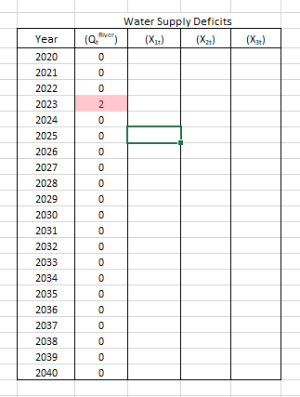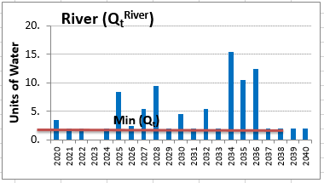

You can count the number of time steps (n), the number of deficits (# of deficits) and the total volume of deficits (Sum of deficits) as follows:

n -> Cell D109: “=COUNT(D87:D107)”

# of deficits -> Cell D110: “=COUNTIF(D87:D107,">0")”

# of NO deficits -> Cell D111: “=COUNTIF(D87:D107,"=0")”

Sum of deficits -> Cell D112: “=SUMIF(D87:D107,">0")”

Sum of Water Demand -> Cell D113: “=River_WD*D109”

Sum of Water Supplied -> Cell D114: “=D113-D112”

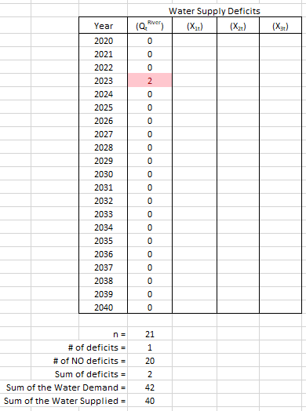

According to the equation of reliability in time, we can estimate it as follows:

$${Reliability(time)}^{i}=\frac{\# of times {Deficit}_{t}^{i}=0}{n}$$

Reliability in time -> Cell D116: “=D111/D109”. The time-based reliability means that 95% of the time the water demand of the river can be fully supplied.

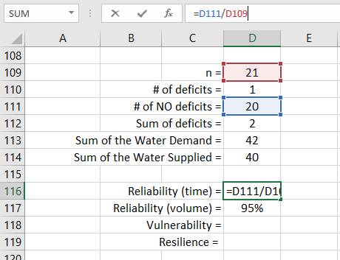

According to the equation of volumetric reliability, we can estimate it as follows:

$${Reliability(volume)}^{i}=\frac{\sum{X_{Supplied,t}^{i}}}{\sum{X_{Demand,t}^{i}}}$$

Volumetric Reliability -> Cell D117: “=D114/D113”. The volumetric reliability means that 95% of the volume requested by the River was able to be supplied.

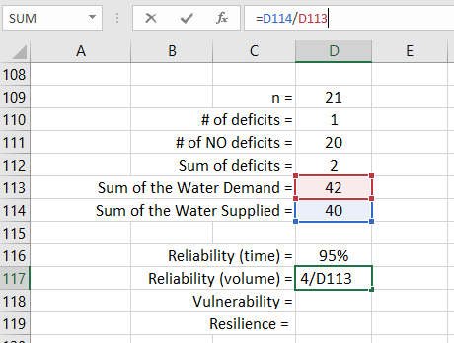

### Vulnerability

The performance criterion of vulnerability expresses the severity of the deficits. In summary, it is the average of the water supply deficits, expressed as a percentage of the water demand. Vulnerability can be calculated as follows:

$${Vulnerability}^{i}=\frac{\left(\frac{\sum{Deficit_{t}^{i}}}{\# of times {Deficit}_{t}^{i}>0 occured }\right)}{{Water Demand}^{i}}$$

Vulnerability -> Cell D118: “=(D112/D110)/River_WD”. The vulnerability criterion means that when a deficit happens, on average, the magnitude of the deficit is 100% of the water demanded by the river.

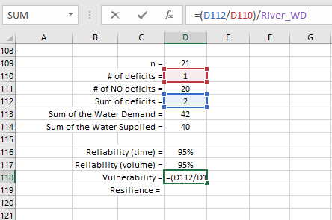

One tricky thing about the Vulnerability is to calculate it when no deficit occur. For this case, the system is considered 0% vulnerable. Thus, the equation in Cell D118 should be changed to account for this peculiar condition as follows: “=IF(D110=0,0,(D112/D110)/River_WD)”.

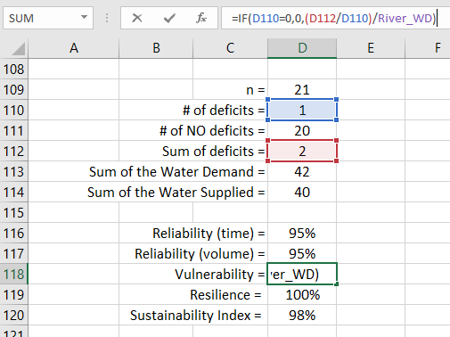

### Resilience

Resilience is the system’s capacity to adapt to changing conditions, resilience must be considered as a statistic that assesses the flexibility of water management policies to adapt to changing conditions. The classic definition of resilience is the probability that a system recovers from a period of failure, e.g., a deficit in water supply. For our specific case, Resilience is the probability that a year of no-deficit follows a year of deficit in the water supply for the *i*th water user. Resilience is a useful statistic to assess the recovery of the system once it has failed. Resilience is expressed as:

$${Resilience}^{i}=\frac{\# of times {Deficit}_{t}^{i}=0 follows {Deficit}_{t}^{i}>0}{\# of times {Deficit}_{t}^{i}>0 ocurred}$$

To estimate Resilience, we need to create a matrix that track the number of times a period of No Deficit follow a period with Deficit. We will always start the first time step with zeros.

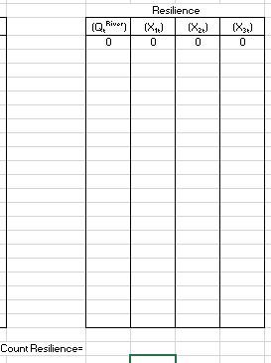

For year 2021, we can estimate if the previous year was in a water supply deficit AND this year is not in a deficit in cell I88 as follows: “=IF(AND(D88=0,D87>0),1,0)”. This equation flags (inserting a 1) if the previous year was in a deficit and the current year is not. The following figure shows that only in year 2024 the previous condition is true, meaning that the previous year (2023) was in a water supply deficit and that the current year (2024) it is not.

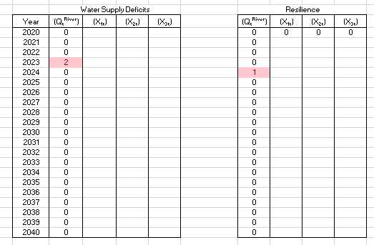

You can sum all of the times this condition occurs in Cell I109: “=SUM(I87:I107)”

The resilience can be calculated as follows:

$${Res}^{i}=\frac{\# of times {Deficit}_{t}^{i}=0 follows {Deficit}_{t}^{i}>0}{\# of times {Deficit}_{t}^{i}>0 ocurred}$$

Resilience -> Cell D119: “=IF(I109=0,1,I109/D110)”. The resilience criterion means the probability that a water demands recovers from a deficit, when they occur. For the River water demand, there is a 100% probability that the system will recover.

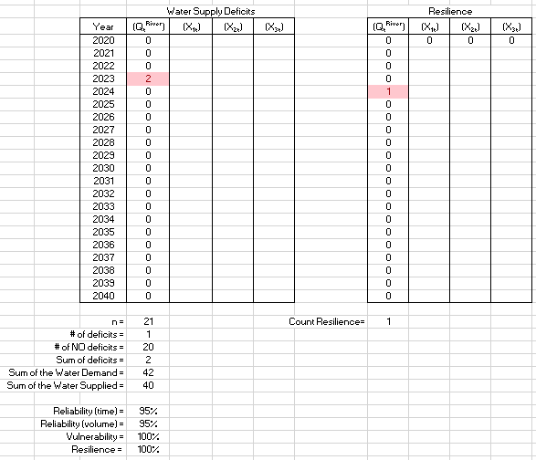

One tricky thing about the Resilience is to calculate the resilience of a system when no deficit occurs. For this case, the system is considered 100% resilient. Thus, the equation in Cell D119 should be changed to account for this peculiar condition as follows: “=IF(I109=0,1,I109/D110)”.

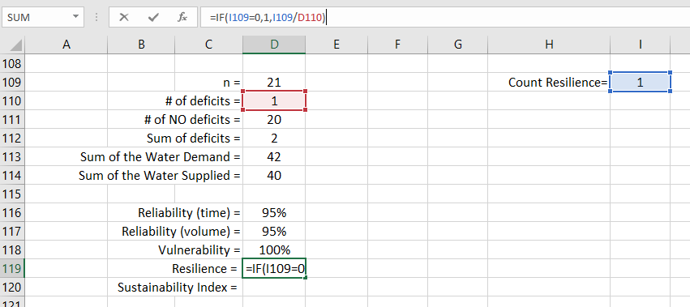

### Water Resources Sustainability Index

Now, think about this: How do you know that a given user is receiving adequately their water demand? So far, we have estimated four performance criteria, but imagine that we start evaluating several alternative water management strategies and all of a sudden some criteria starts going up other going down. Can we estimate a single number (an Index) that summarize the performance of a given water demand? In order to summarize all the performance criteria, we used index that helps synthesizing results. The Water Resources Sustainability Index (SI) is an index that aggregates a set of performance criteria, it is the geometric average of a group of *m* performance criteria for a given water user *i*:

$${SI}^{i}={\left[\prod_{m=1}^{M}{{Performance Criteria}_{m}^{i}}\right]}^{1/M}$$

For our case, the SI can be expressed as:

$${SI}^{i}={\left[Rel{\left(time\right)}^{i}*Rel{\left(Volume\right)}^{i}*Res^{i}*(1-Vuln^{i})\right]}^{1/4}$$

For the River water demand, the SI can be estimated in Cell D120 as follows:  
Cell D120: “=(D116*D117*D119*(1-D118))^(1/4)”

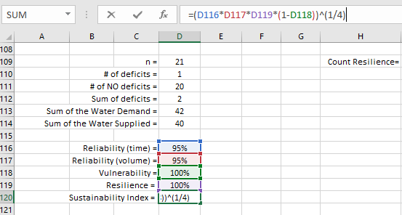

Figure 17. Results of the Performance Criteria and Sustainability Index for the River Water demand

For the River water demand, the SI = 0% meaning that is unsustainable. While the Reliability (in time and volume) is very high (95%) and the resilience is very high (100%), when a deficit occurs, this deficit is very damaging, 100% of the water demand. That’s the reason why the SI = 0%

### Instructions

Calculate the deficit matrix for users 1, 2 and 3.

Hint: for year 2020, the deficit can be calculated as follows:   
User1 -> Cell E87: “=IF(E59<X1_WD,**X1_WD**-E59,0)”  
User2 -> Cell F87: “=IF(F59<X2_WD,**X2_WD**-F59,0)”  
User3 -> Cell G87: “=IF(G59<X3_WD,**X3_WD**-G59,0)”

Calculate the following variables for Users 1, 2 and 3: n, # of deficits, # of NO deficits, Sum of deficits, Sum of Water Demand, and Sum of Water Supplied

Hint: Remember to use the appropriate water demands for user 1 (**X1_WD**), 2 (**X2_WD**), and 3 (**X3_WD**) in the equation of Sum of Water Demand.

Calculate the resilience matrix for Users 1, 2 and 3

Estimate the Reliability (time-based and volumetric), Vulnerability, resilience and Water resources Sustainability Index for user 1, 2 and 3.

Hint: Remember to use the appropriate water demands for user 1 (**X1_WD**), 2 (**X2_WD**), and 3 (**X3_WD**) in the equation of Vulnerability.

**To be turned in:**

1. Show table (like figure 17) of the four performance criteria [Reliability(time and volume), vulnerability and resilience) and the Sustainability Index.
2. Change the value of the *River* water demand (*QtRiver* ) to 4 units in cell C54. Show a table like the one calculated in Figure 15 and the series of graphs calculated in Figure 16.
3. Show table (like figure 17) of the four performance criteria [Reliability(time and volume), vulnerability and resilience) and the Sustainability Index for all water demands for *QtRiver* = 4 units. Does the water supply for *Users 1, 2 and 3* change? Does it improved or got worse?
4. Calculate the average annual flow coming from upstream (*QtIn*) (Average of cells C59:C79). How much the River water demand represent in comparison to the average annual inflows [ River_WD / Avg. (*QtIn*) ]? Do you think this is enough water so the ecosystem can be sustained? Imagine that from your total monthly income (let say $2,000), this monthly stipend is reduced to the same percentage of water that was left in the river (let say 30% of $2,000 = $600). Can you adequately live with this budget in a month? Do you see any similitude with what we have left to the river? Elaborate why there may be a conflict with human and environmental water supply.

## River and Reservoir System

Now, you are going to be working with a reservoir system, how exciting!

Before declaring any equation, it will be easier if we define names in this workbook as you did in the previous part of the exercise. Once again, make sure you are in the “**Part 2 – Reservoir**” sheet. Go to cell C54. Then, go to the menu of Formulas and click on “Define Name”. A dialogue window should come out, you should name the variable “River_WD” as you did before which as a short name of “River Water Demand”. Very important, make sure that in “Scope:” drop down menu you select “**Part 2 - Reservoir**”. By default the “Refers to:” section should be selecting the cell C54 where the cursor is located. If this is not showing, click on the “cells and arrow” icon on the right and select the cell C54. By doing this, you are naming that cell “River_WD” that you will be able to call it like this worksheet in excel, cool, isn’t it!

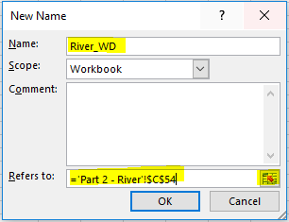

You will have to “Define Name” for the following variables and cells:

|  |  |
| --- | --- |
| **“Define Name” Variable** | **Cell** |
| River_WD | C54 |
| X1_WD | D54 |
| X2_WD | E54 |
| X3_WD | F54 |
| K | J54 |
| Hedging | K54 |

If you had a problem naming your variables or not selecting the right cell, you can click on the Formulas/Name Manager where you can delete or edit you variables



The same file has a system set up with a reservoir, with capacity ***K*=25 units**, and initial storage ***S0*= 7 units**, as shown below.

|  |  |  |  |  |
| --- | --- | --- | --- | --- |
| Water Demands | | | | |
| Priority | 1 | 3 | 3 | 2 |
| Name | River | User 1 | User 2 | User 3 |
| Nickname | (QtRiver) | (X1t) | (X2t) | (X3t) |
| Volume | 2 | 2.5 | 3 | 5 |

  
Figure 17

The only difference in the allocation policy is that for *User 1*, *User 2* and *User 3*, you will have to substitute ***St-1+Qtin*** instead of ***Qtin*** in each of the conditionals. For River, *QtRiver*, the water allocation changes as follow:

$$Q_{t}^{River}=\left\{\begin{matrix}Q_{t}^{in}+S_{t-1} & if & Q_{t}^{In}+S_{t-1}<2 \\ 2 & if & Q_{t}^{In}+S_{t-1}≥2\end{matrix}\right.$$

In addition, reservoir spills must be calculated (Column G, Cells G6:G40) as follow:

$$Q_{t}^{Spill}=\left\{\begin{matrix}0 & if & S_{t-1}+Q_{t}^{in}≤K+Q_{t}^{River}+\sum_{i=1}^{i=3}{X_{it}} \\ \left(S_{t-1}+Q_{t}^{in}\right)-\left(K+Q_{t}^{River}+\sum_{i=1}^{i=3}{X_{it}}\right) & if & S_{t-1}+Q_{t}^{in}>K+Q_{t}^{River}+\sum_{i=1}^{i=3}{X_{it}}\end{matrix}\right.$$

1. Please write down a paragraph explaining in plain words how the operation for River has changed, such as the one used in the River System:

“*River* has the first priority, at least 2 units of water should be left in the river (if available) before the rest of the users can take their water demand. [Insert here how the water allocation policy has changed for River].”

Hint: In order for the river to receive extra water, does the reservoir have to spill?

1. Calculate the spills (Column G, Cells G6:G40) using the equation provided above.
2. Estimate the table for the water allocation policy (cells B2:H40) and show this table.
3. Estimate in column D the St-1+Qtin.
4. Use any of the two methods explained above to link the water allocation policy table with the mass balance model for the River (E59:E79), User 1 (F59:F79), User 2 (G59:G79) and User 3 (H59:H79).
5. Using the mass balance equation, estimate the reservoir storage through every time step (I59:I79). Remember that the storage can’t exceed the storage capacity K=25 units.
6. Use any of the two methods explained above to link the water allocation policy table with the mass balance model for Reservoir spills (J59:J79),
7. Display the mass balance results, like figure 15 and 16.
8. Similarly, does the water supply for Users 1, 2 and 3 improved if the reservoir is built? Show a comparison of the water supply for both systems (With and without a reservoir ***QtRiver* = 2 units** in both calculations)
9. What about the River? Does the river improve their water supply?
10. Show table (like figure 17) of the four performance criteria [Reliability(time and volume), vulnerability and resilience) and the Sustainability Index.
11. Did the performance of the systems improved or got worse? Create a table showing a comparison the performance criteria and

# Optimization Modeling

## Objective

The objective of this exercise is to provide a set of problems using simple optimization techniques as well as the basics of linear programming using a linear optimization solver in Excel.

### Useful Formulas

Find the decision variables, ***x***, that optimizes (maximizes or minimizes) an objective function.

For instance, to minimize:

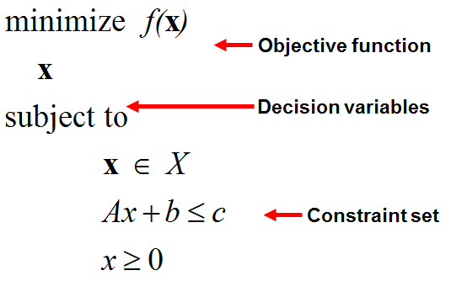

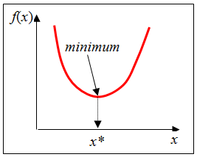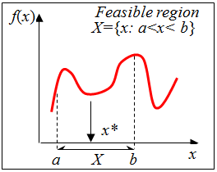

## Steps for Linear Programming

In order to solve linear programing, these are 7 steps that you should follow to identify the maximum or minimum value for the objective function at hand:

1. Define the *optimization purpose*. Is the objective to **Maximize or Minimize**?
2. Define *Objective Function*, or in other words, write the Objective Function into an equation. If the equation is linear (Z=ax1+bx2), it can be solved through a linear programming. If not, other techniques of non-linear programing can be used to solve this type of problem.
3. Define the Constraints. Write the constraints into inequalities, so they can be used to define the Feasible Region. Notice that the statement “the value of x is greater than (or at least) 20” means x≥20, and the statement “the value of x is smaller than (or less than) 20” means x≤20
4. Define the Feasible Region. Use the constraints (inequalities) to bound the feasible region. For constraints with the form “ax1+bx2≤C”, convert them into equations by dropping the “≤” or “≥” symbol and adding the equal sign “=”, such as “ax1+bx2=C”. Then solve the equation for x1=0 to obtain the point where the linear equation crosses the x1 axis. Similarly, solve for x2=0 to obtain the point where the linear equation cross the x2 axis.
5. Obtain the vertices of the feasible region. Do this by identifying the points in the feasible region and, for the constraints with the form “ax1+bx2≤C”, convert them into equations “ax1+bx2=C” and obtain the value of the unknown variable, either x1 or x2, by solving the equation.
6. Substitute vertices into the Objective Function. Substitute the values of the variables (x1 and x2) at the vertices into the objective function equation.
7. Select the values of the variables that are the maximum or minimum for the objective function, depending on the definition of the objective function (Step 1).

### Installing Open Solver - Model

Installing the Open Solver in excel.

1.- Copy the OpenSolver21.zip into your computer.

2.- Unzip this file

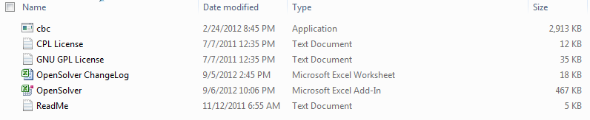

3.- Double click on the file: “OpenSolver” which is the add-In

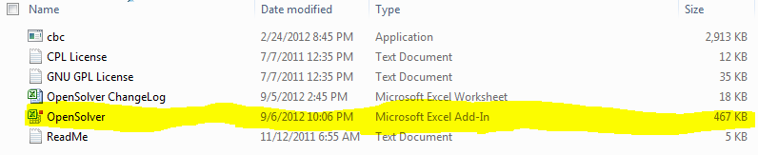

4.- If a dialogue-window pops up, please select “enable macros”

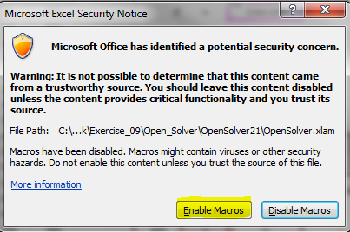

5.- On the data menu of Excel you should see the Open Solver add-in in the right corner of the menu.

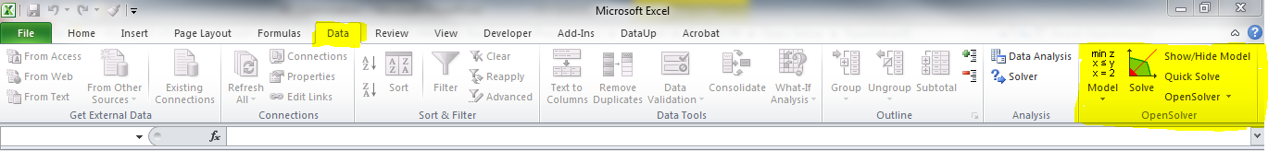

6.- Finally Open the file Ex_5.xlsx

## Exercise 1 (Adapted from McKinney).

Based on an annual water allocation of 1,800 acre-feet (AF), an irrigation district wants to know how they can maximize their profits by growing two types of crops, Crop A and Crop B. The profits can be obtained by summing the profit (*CA* and *CB*) times the acreage (*XA* and *XB*) for each crop. The irrigation district has constraints. The first constraint is the water use, which is the sum of the water requirement times the acreage for each crop, which must be equal or less than the water allocation (1,800 AF). Second, there are limits to growing one crop or another. The maximum acreage on which to grow crop *A* is 400 acre, and crop *B* is 600 acres. Lastly, the acreage must be a positive number for both crops. Table 1 shows the water requirement, expected profit per acre and maximum area cultivated for each crop.

Table 1

|  |  |  |
| --- | --- | --- |
|  | **Crop A** | **Crop B** |
| Water requirement (Acre feet/acre) | 3 | 2 |
| Profit ($/acre) | 300 | 500 |
| Max area (acres) | 400 | 600 |

***To be turned in:***

1. Write down the objective equations and constraints for this problem. Take a look at the “Optimization Presentation”, this exercise was explained in this presentation.
2. Copy the chart for the feasible region located in Ex_5.xlsx file tab “1 Maximize”
3. What was the solution (Maximum value for the objective function *Z*) in the presentation?

Now, let’s work on the Ex_5.xlsx file. Open the tab “1 Maximize”. The right side of that tab should look like Figure 1. Every cell that is orange means you must declare some information there.

### Variables and Objective Function

First, let’s start with the *Variables*. We need to give the model a first guess of the variable, usually any value inside the feasible region and the model will take care to later give us the right result once we have run it. For *XA* lets define an initial value of 400 (cell T4=400), and for *XB* a value of 600 (cell T5=600), see Figure 2.

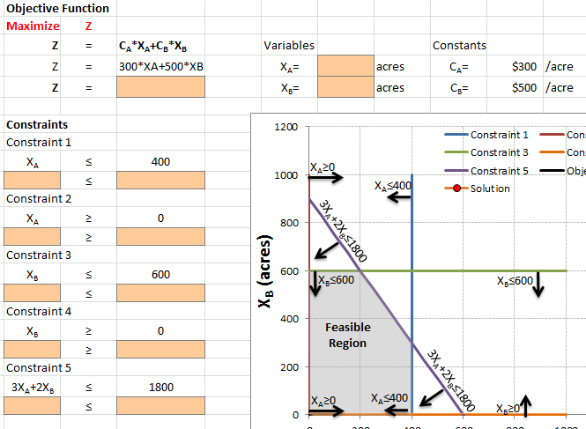

Figure 1

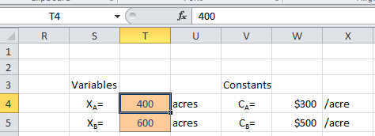

Figure 2

Now let’s define the Objective function in cell Q5 as the sum of the multiplication of the acreage times the profits for each crop (cell Q5 =T4*W4+T5*W5), see Figure 3.

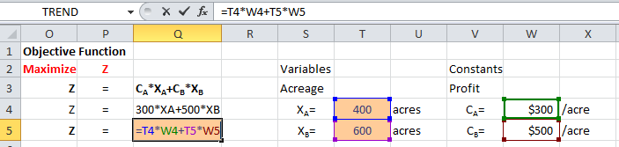

Figure 3

### Constraints

Now let’s work on the *Constraints*. Constraint 1 specifies that the acreage of crop a (*XA*) must be equal to or less than 400 acres. Link cell O10 with the value of *XA* (cell T4) by typing in cell O10 “=T4”; see Figure 4. Type in cell Q10 the constraint value of 400 (Figure 5).

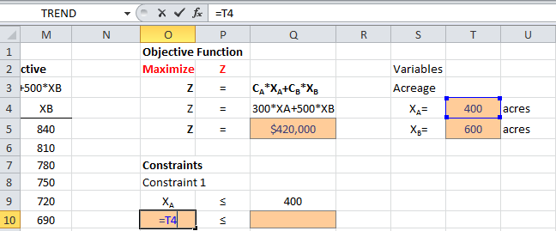

Figure 4

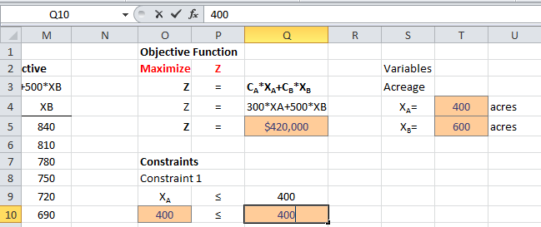

Figure 5

Constraint 2 specifies that the acreage of crop A (XA) must be equal to or greater than 0 acres. Link cell O13 with the value of XA (cell T4) by typing in cell O13 “=T4”; see Figure 6. Type in cell Q13 the constraint value of 0 (Figure 7).

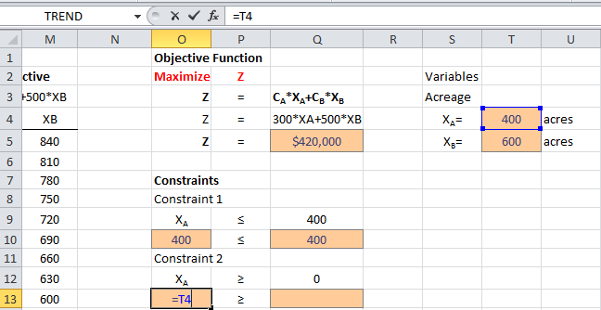

Figure 6

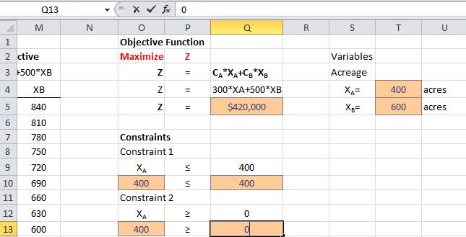

Figure 7

Constraint 3 specifies that the acreage of crop B (*XB*) must be equal to or less than 600 acres. Link cell O16 with the value of *XB* (cell T5) by typing in cell O16 “=T5”; see Figure 8. Type in cell Q16 the constraint value of 600 (Figure 9).

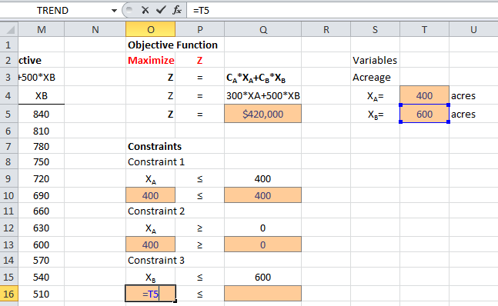

Figure 8

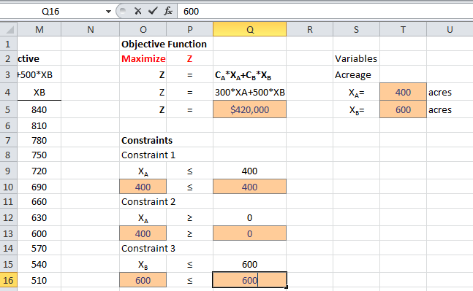

Figure 9

Constraint 4 specifies that the acreage of crop B (*XB*) must be equal or greater than 0 acres. Link cell O19 with the value of *XB* (cell T5) by typing in cell O19 “=T5”; see Figure 10. Type in cell Q19 the constraint value of 0 (Figure 11).

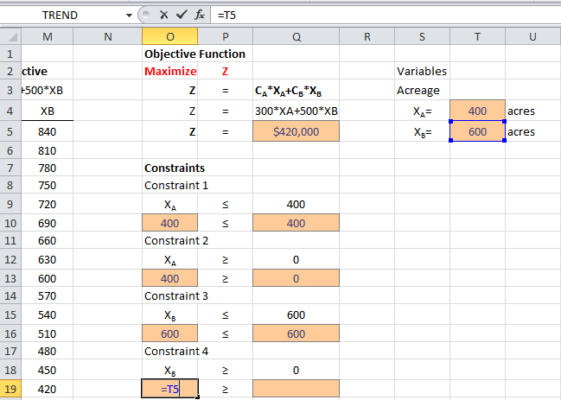

Figure 10

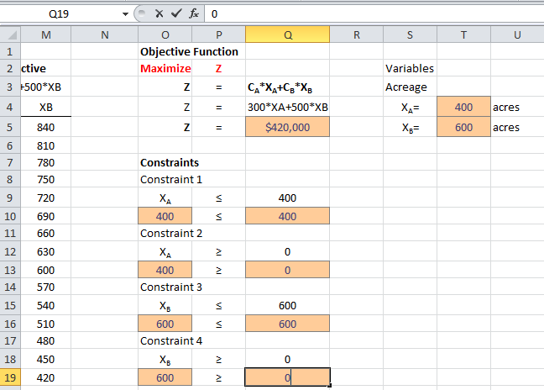

Figure 11

Constraint 5 specifies that the sum of the water use in crop A (3\**XA*) and crop B (2\**XB*) must be equal or less than 1800 acre-feet. In cell O22 we have to write this equation as follow: “=Z4*T4+Z5*T5”; see Figure 12. Type in cell Q19 the constraint value of 1800 (Figure 13).

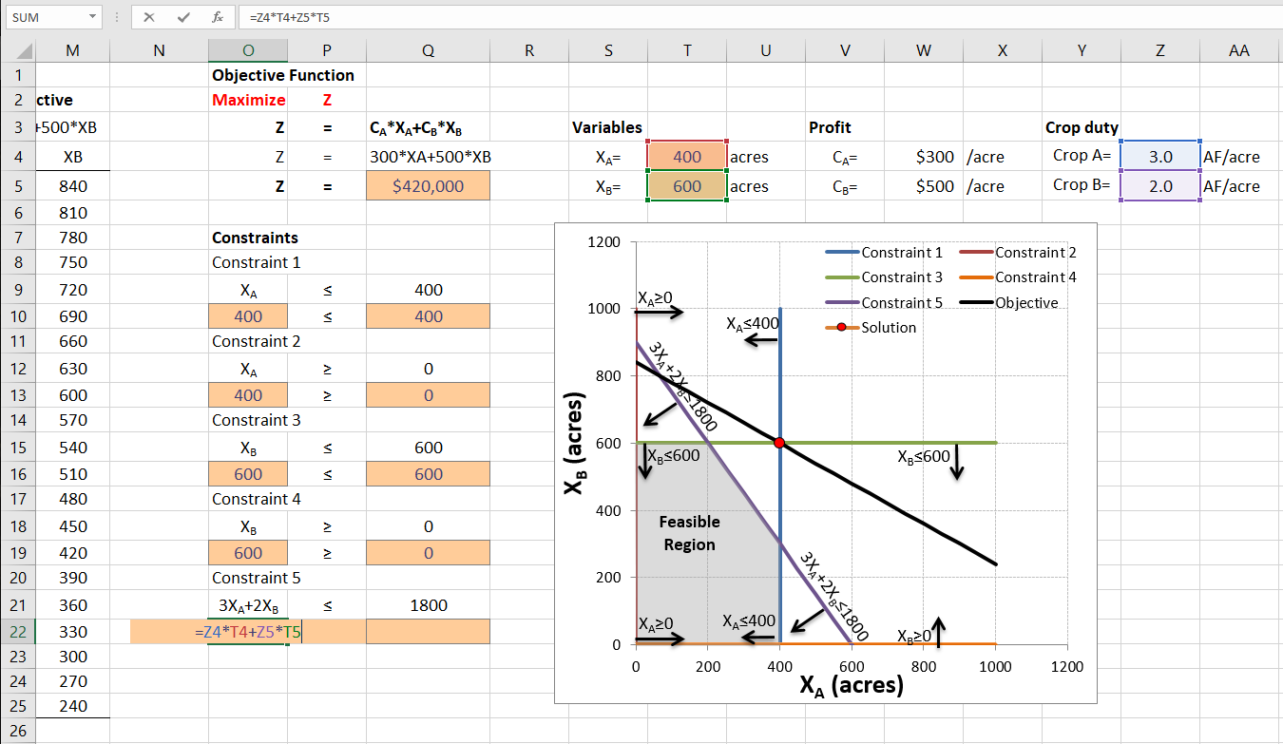

Figure 12

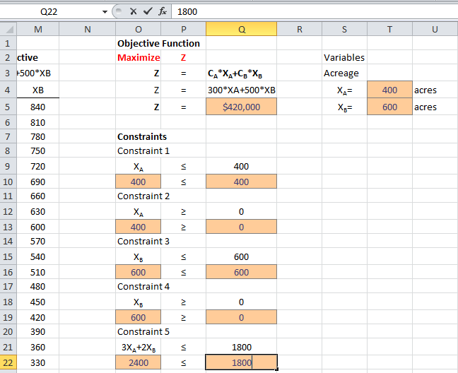

Figure 13

Save your spreadsheet (Ctrl+S).

### Defining the Optimization Linear Program

Now, let’s define the linear program model. Go to the Data menu and click on “Min Z x≤y x=2 Model” icon (Figure 14)

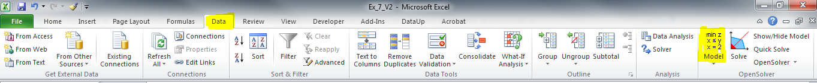

Figure 14

A dialogue window will appear, displaying the “Open Solver - Model” (Figure 15).

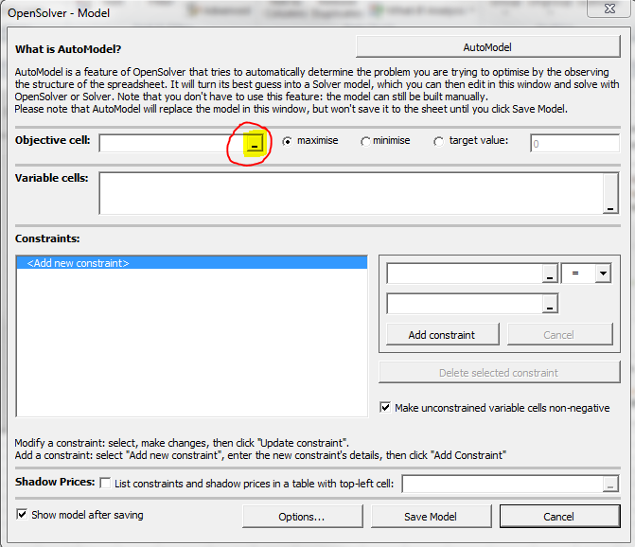

Figure 15

Go to the Objective cell section, and click on the icon to browse the objective cell (Figure 15). Select the cell Q5, which is the cell with the equation of the objective function (Figure 16).

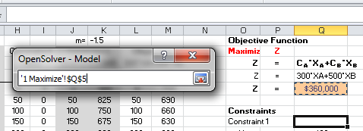

Figure 16

When you come back to the dialogue window, make sure to select “maximize” (Figure 17).

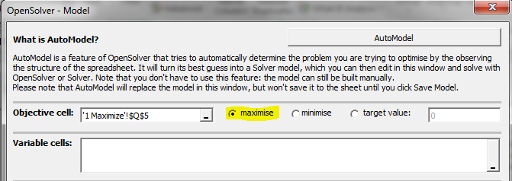

Figure 17

Now click on the icon to choose the cells that will be the variables (Figure 18). Select cells T4 and T5 (Figure 19).

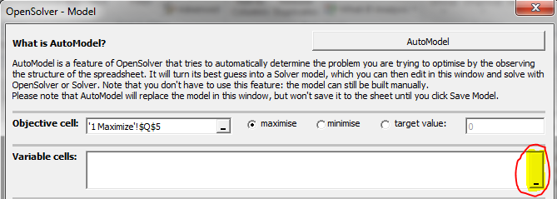

Figure 18

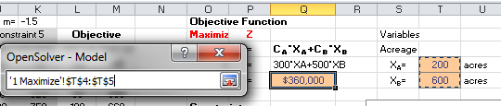

Figure 19

Now, we will add the constraints to the model. Let’s start with the first constraint (XA≤400), go to the constraints section and click on the icon to browse for the left hand side of the constraint (Figure 20). Select the cell O10 (Figure 21), then go back to the dialogue menu. Select the symbol of equal or less than “≤” (Figure 22). Now click on the icon to select the right side of the inequality (Figure 23), cell Q10 (Figure 24) and go back the dialogue window. Click on “Add Constraint” (Figure 25). The inequality Cell O10 ≤ Cell Q10 should have appeared in the left side of the Constraints section of the dialogue window (Figure 26). We just have finished declaring the first constraint.

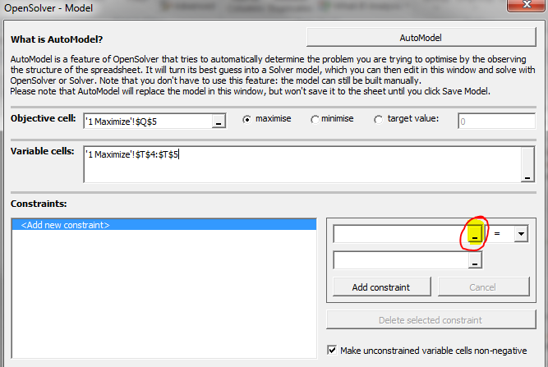

Figure 20

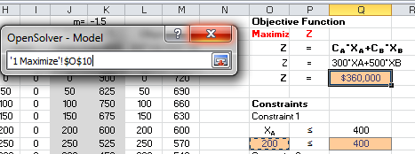

Figure 21

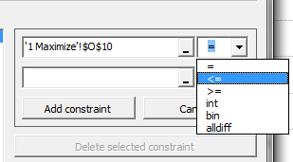

Figure 22

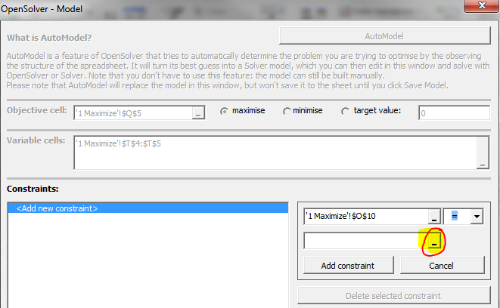

Figure 23

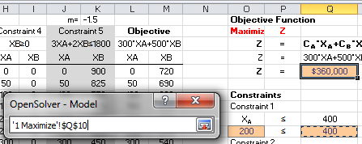

Figure 24

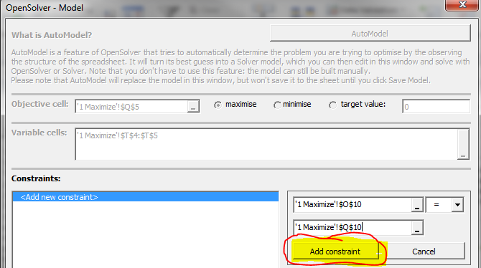

Figure 25

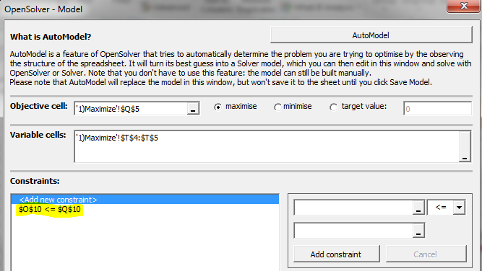

Figure 26

To declare the second constraint (*XA* ≥ 0), click on the icon to browse for the left hand side of the constraint (Figure 20). Select the cell O13 (Figure 27), then go back to the dialogue menu. Select the symbol of equal or greater than “≥” (Figure 22). Now click on the icon to select right-side part of the inequality (Figure 23), select cell Q13 (Figure 29) and go back the dialogue window. Click on “Add Constraint”. The inequality Cell O13 ≥ Cell Q13 should have appeared in the left side of the Constraints section of the dialogue window (Figure 30).

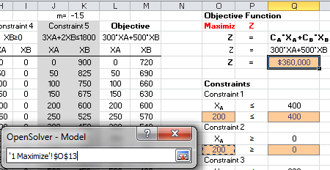

Figure 27

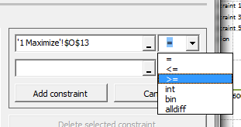

Figure 28

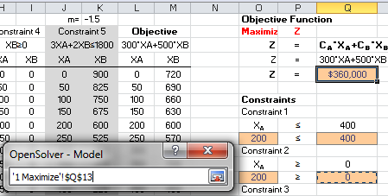

Figure 29

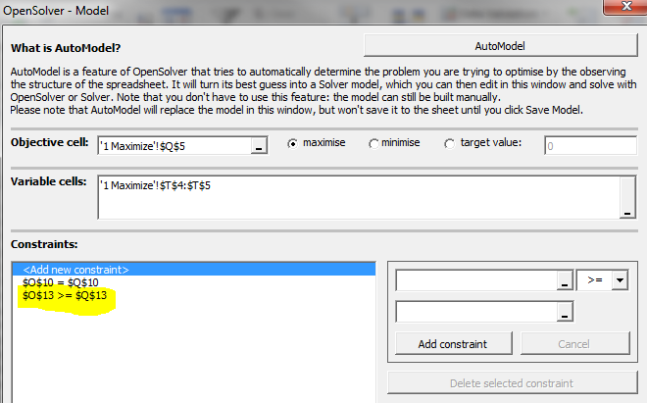

Figure 30

To declare the third constraint (*XB* ≤ 600), click on the icon to browse for the left hand side of the constraint (Figure 20). Select the cell O16 (Figure 31), then go back to the dialogue menu. Select the symbol of equal or greater than “≤” (Figure 32). Now click on the icon to select right-side part of the inequality (Figure 23), select cell Q16 (Figure 33) and go back the dialogue window. Click on “Add Constraint”. The inequality of cell O16 ≤ Cell Q16 should have appeared in the left side of the Constraints section of the dialogue window (Figure 34).

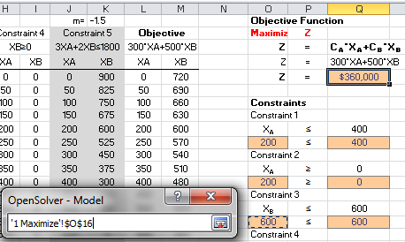

Figure 31



Figure 32

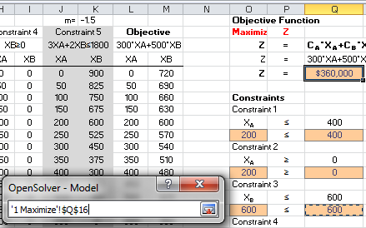

Figure 33

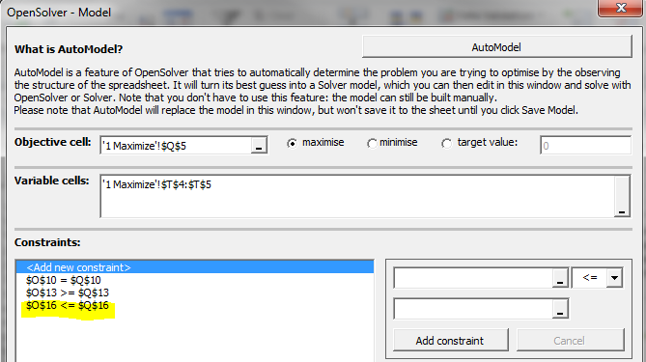

Figure 34

To declare the fourth constraint (*XB* ≥ 0), click on the icon to browse for the left hand side of the constraint (Figure 20). Select the cell O19 (Figure 35), then go back to the dialogue menu. Select the symbol of equal or greater than “≥” (Figure 36). Now click on the icon to select right-side part of the inequality (Figure 23), select cell Q19 (Figure 37) and go back the dialogue window. Click on “Add Constraint”. The inequality Cell O19 ≥ Cell Q19 should have appeared in the left side of the Constraints section of the dialogue window (Figure 38).

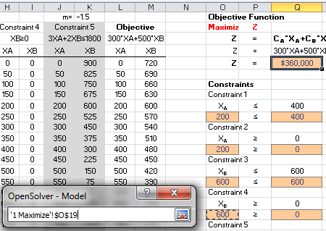

Figure 35



Figure 36

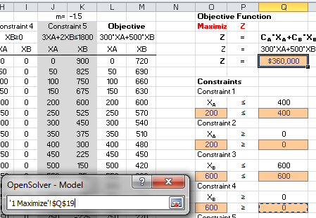

Figure 37

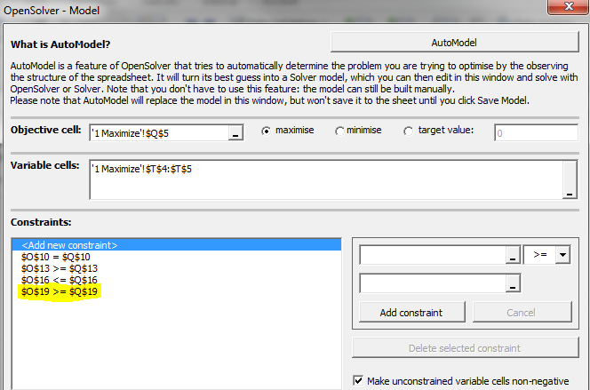

Figure 38

To declare the fifth constraint (3*XA*+2*XB* ≤ 1800), click on the icon to browse for the left hand side of the constraint (Figure 20). Select the cell O22 (Figure 39), then go back to the dialogue menu. Select the symbol of equal or greater than “≤” (Figure 40). Now click on the icon to select right-side part of the inequality (Figure 23), select cell Q22 (Figure 41) and go back the dialogue window. Click on “Add Constraint”. The inequality of cell O22 ≥ Cell Q22 should have appeared in the left side of the Constraints section of the dialogue window (Figure 42).

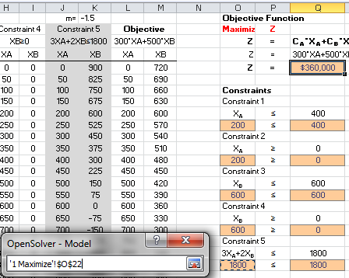

Figure 39



Figure 40

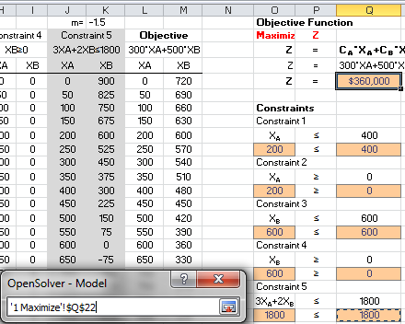

Figure 41

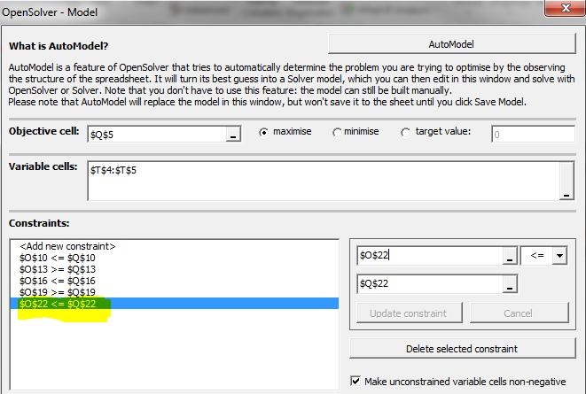

Figure 42

Check the box that says “List constraints and shadow prices in a table with top left cell:” and select the cell “AC8” (Figure 43)

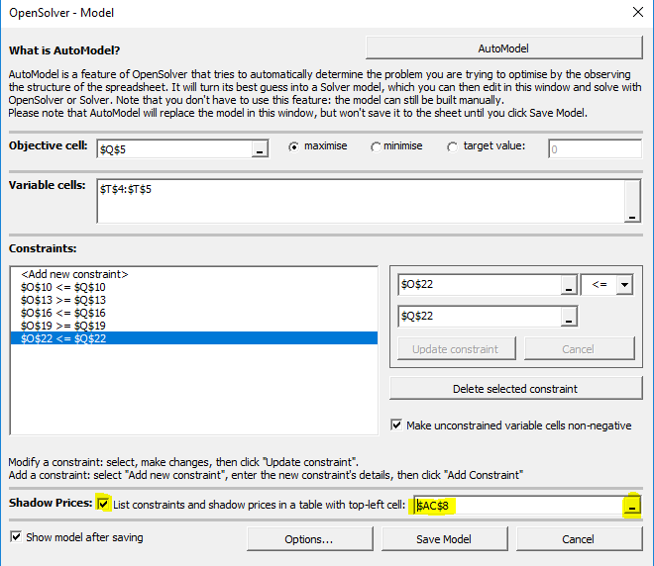

Figure 43

Click on “Save Model” (Figure 44). A Series of colorful rectangles should have appeared in your Spreadsheet (Figure 45). Notice that the Objective Function (cell Q5) has a “Max” label on top of it. Also, notice that the variables have a pink rectangle on top. In addition, for each constraint the right and left side of the equations/inequality are related with a line and a symbol (“≥”, “≤” or “=”), Double check that these symbols are correct.

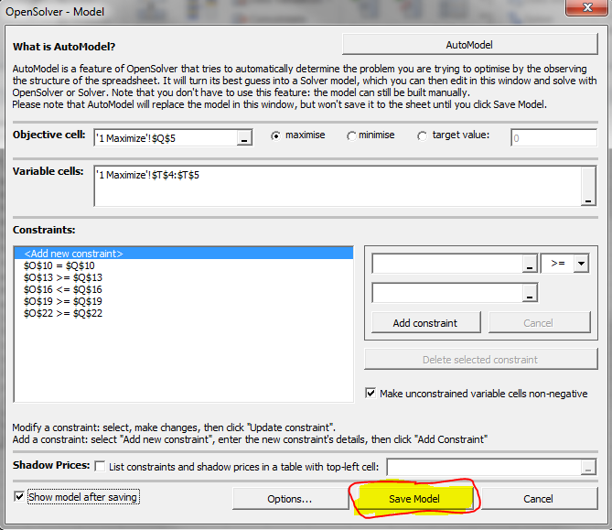

Figure 44

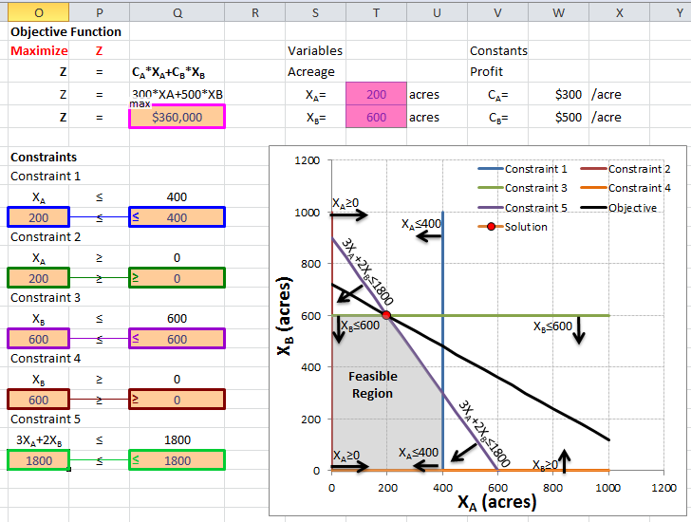  
Figure 45

### Running the Linear Programming Model

It is time to run the model!!! Click on the Solve icon (Figure 46) of the Open Solver. After the screen blinks you will notice that numbers have changed. The maximum profit that can be obtained are **$360,000 (Cell Q5)**!!! The values for the variable have changed, *XA*=200 and *XB*=600, as we calculated in the presentation at class!!!

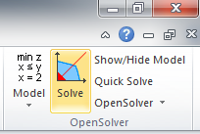

Figure 46

### To be turned in:

1. Take a look at the shadow values. For the constraint in cells O16<=Q16 (XB≤600) the shadow value is equal to -300, what does it mean? *Do the following to get a hint for the answer of this question*: Change the value of cell Q16 to 601 and run the model. What is the new value of the objective function (cell Q5)? Now change it to 602, and take a look at the objective function value. How much the objective value changed for 601? And for 602? And for 603? Does the shadow price tell you how much the objective function will change by a unit increase in the constraint?
2. A screenshot of the model, like Figure 45.
3. Now let’s invert the values so the Profits for *CA* (cell W4) are equal to $500/acre and for *CB* (cell W5) are equal to $300/acre. Click on Solve. What are the results for XA and XB? Does the value of the profits change the results for the optimal solution? If so, do you think changing the market prices can change the optimal solution of linear systems?
4. A screenshot of the new model with the profit values changed.

## Exercise 2 (Adapted from Loucks and van Beek)

A city planner wants to know the minimum cost of waste removal (WR) at Sites 1 and 2 upstream of a recreational park (Figure 47). The cost of waste removal can be obtained by summing the cost of 100% (*C1* and *C2*) times the fraction of removal for each site (*X1* and *X2*). According to a pre-design, the fraction of WR at site 1 (*X1*) must be equal to or greater than 0.8 but equal to or less than 1. The fraction of WR at site 2 (*X2*) must be equal to or less than 1. There is another constraint expressed as the equation: *X1* +1.3 *X2* ≥ 1.8.

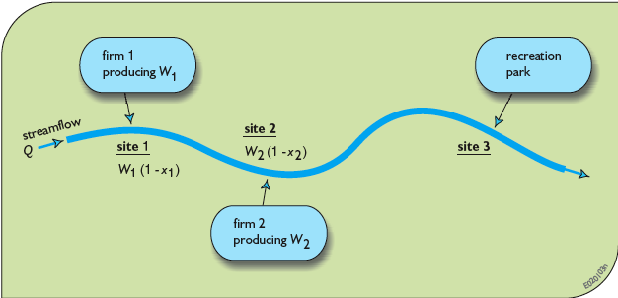

Figure 47.

Use the “Optimization” presentation in class to solve this problem. The optimization model is as follows:

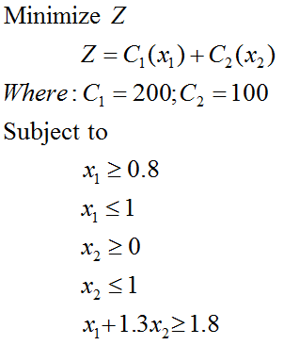

Using the Excel spreadsheet Ex_5.xlsx in Tab “2) Minimize”, create a linear program using the Open Solver Model. Don’t forget to select “**Minimize**” instead of “Maximize” (Figure 17) when creating the linear model.

***To be turned in:***

1. A screenshot of your linear model, such as Figure 44.
2. What is the minimum cost of removal (the optimum value of the objective function) obtained once the model has been run? How do your results compare with the ones in the presentation (Slide 20, minimum cost of removal equal to $238K)

## Exercise 3 The perfect outfit! Extra credits (+20%)

Summer is coming and you are looking for the perfect outfit to wear, while, at the trying not to over spend. You have a total budget of $130. This is a suggested number of minimum and maximum number of pieces that you want to buy for each article.

|  |  |  |
| --- | --- | --- |
| Article | Minimun # of pieces | Maximum # of Pieces |
| Jeans (*CJeans*) | 1 | 3 |
| T-Shirts (*CT-shirts*) | 1 | 4 |

Other constraints are that you want to buy equal or more T-shirts than jeans (CT-shirts≥CJeans), and that the total amount spent should not be more than your dedicated budget $130.

***To be turned in:***

Following the seven steps of linear programing (page 4 of this exercise)

1. Write down the *objective function* and the constraints
2. Draw the *feasible region*. You can use excel, or a simple piece of paper and scan it, or some engineering paper.
3. Obtain the vertices of the feasible region. Substitute the values of the vertices into the objective function. Submit a table showing the vertices of the feasible region as well as the value of the objective function for each pair of *CJeans* and *CT-shirts* values (see slides 13 and 19 of the presentation of “Optimization”).
4. Based on the previous analysis, what is the combination Jeans and T-shirts that you should buy?

Now, let’s use the Open Solver model of excel to solve this problem. Use the file Ex_5.xlsx - tab “3 Maximize” to create a linear optimization model. You can use as initial values for *CJeans* (cell G5) and *CT-shirt* (cell G6) 1 and 1, respectively. Calculate amount spend in cell D6 (for the objective function) and B23 (for the constraint) by multiplying the cost of the jeans times the number of jeans (J5xG5) plus the cost of T=shirts times the number of T-shirts (J6xG6). When creating the linear optimization model in Open Solver, don’t forget to select “Maximize” (Figure 17). In addition, you will have to declare in the optimization model that the number of jeans *CJeans* (cell G5) and T-shirts *CT-shirts* (cell G6) should be integers (see figure 48).

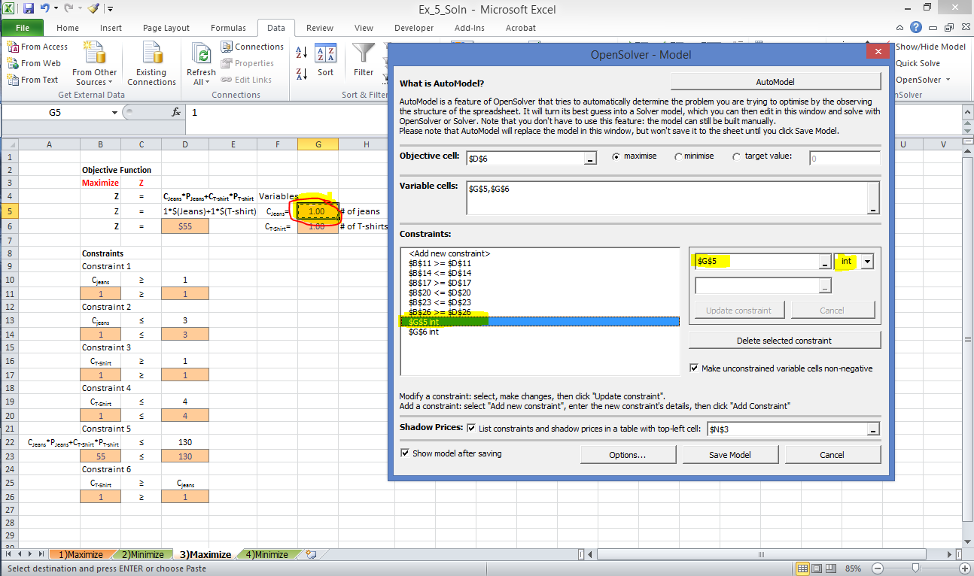

Figure 48

1. Turn in a screenshot of your linear model, similar to Figure 44.
2. How much will you spend (the optimum value of the objective function) obtained once the model has been run (cell D5)?
3. How many Jeans and T-shirts you can buy *CJeans* (cell G5) and *CT-shirts* (cell G6) for the maximum amount of money spent given the constraints?
4. How do these results compare with the same analysis done before in question 4 of this problem (see above)? Are these results similar?
5. What are the shadow prices for the different constraints? What is the maximum shadow price? If you change any constraint “1 unit”, how much will the Objective function will change? Are there any biding constraints?

## Exercise 4 (Adapted from Loucks and van Beek) Extra credits (+20%)

Consider a water-using industry that plans to obtain water from a groundwater aquifer. Two wellfield sites have been identified, *A* and *B*. The objective of this industry is to minimize the cost of pumping from the wells at sites *A* and *B*. The cost of pumping can be obtained by summing the cost of pumping at site *A* plus site *B* (*Cost A + Cost B*); both of them depend on the water extracted *QA* and *QB* from sites *A* and *B*, respectively. Cost A is expressed by the equation:

$$Cost A=8+\frac{40-8}{17}*Q_{A}$$

Cost B is expressed by the equation:

$$Cost B=15+\frac{26-15}{13}*Q_{B}$$

For the well at site *A*, the water extracted (*QA*) must be equal to or greater than 0. The maximum sustainable groundwater extraction at site *A* is equal to or less than 17 acre-feet/year.

For the well at site *B*, the water extracted (*QB*) must be equal to or greater than 0. The maximum sustainable groundwater extraction at site *B* is equal to or less than 13 acre-feet /year.

The water required to satisfy the industry is 22 acre-feet/year.

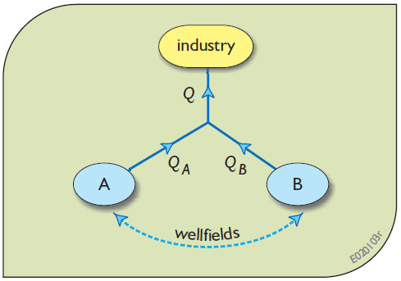

Figure 49

***To be turned in:***

Following the seven steps of linear programing (page 4 of this exercise)

1. Write down the *objective function* and the constraints
2. Draw the *feasible region*. You can use excel, or a simple piece of paper and scan it, or some engineering paper.
3. Obtain the vertices of the feasible region. Substitute the values of the vertices into the objective function. Submit a table showing the vertices of the feasible region as well as the value of the objective function for each pair of *QA* and *QB* values (see slides 13 and 19 of the presentation of “Optimization”).
4. Based on the previous analysis, what is the minimum cost of pumping for this industry?
5. What is the optimal water extraction *QA* and *QB* for the minimum cost of pumping?

Now, let’s use the Open Solver model of excel to solve this problem. Use the file Ex_5.xlsx - tab “4 Minimize” to create a linear optimization model. You can use as initial values for QA (cell G5) and QB (cell G6) 10 and 10 AF/year , respectively. Calculate *Cost A* in cell D8 using the formula provided above. Similarly, calculate *Cost B* in cell D11 using the formula provided above. Don’t forget to link the objective function in cell D5 by summing the *Cost A* (Cell D8) plus *Cost B* (Cell D11). When creating the linear optimization model in Open Solver, don’t forget to select “Minimize” instead of “Maximize” (Figure 17).

1. Turn in a screenshot of your linear model, similar to Figure 44.
2. What is the minimum cost of pumping (the optimum value of the objective function) obtained once the model has been run (cell D5)?
3. What are the optimal water extractions *QA* (cell G5) and *QB* (cell G6) for the minimum cost of pumping?
4. How do these results compare with the same analysis done before in questions 4 and 5 of this problem (see above)? Are these results similar?